2017 Haywood Tomcats Tennis Team

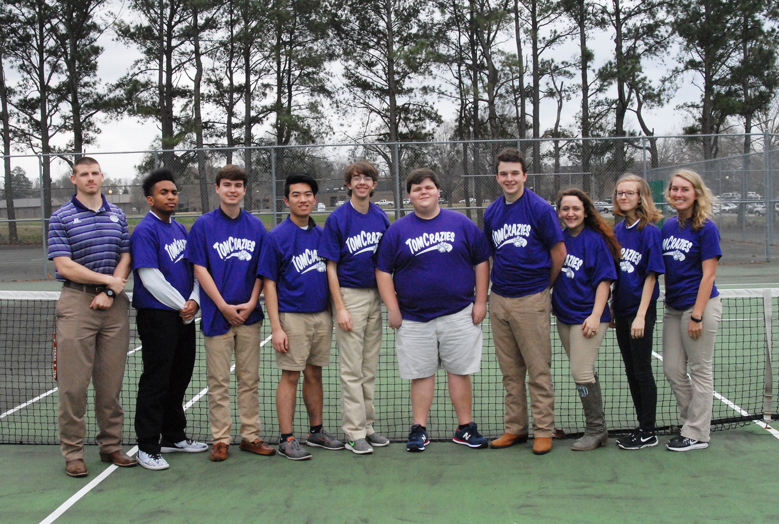
Members of the 2017 Haywood High School Tennis teams are Coach Chris Brackeen Trevor Dancy, Brent Howell, Bendy Yuan-Zhao, Everette Pettigrew, Elliot Garrett, Alex Sceals, Lena Smith, Elizabeth Campbell, and Sadie Sharpe. Not pictured is Gabby Morphis.

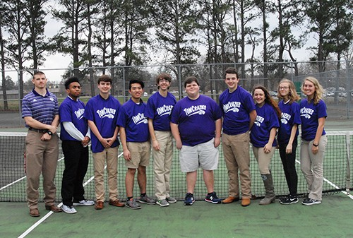
Members of the 2017 Haywood High School Tennis teams are (from left) Coach Chris Brackeen, Trevor Dancy, Brent Howell, Bendy Yuan-Zhao, Everette Pettigrew, Elliot Garrett, Alex Sceals, Lena Smith, Elizabeth Campbell, and Sadie Sharpe. Not pictured is Gabby Morphis.

HHS 2017 TENNIS Schedule
__________________________
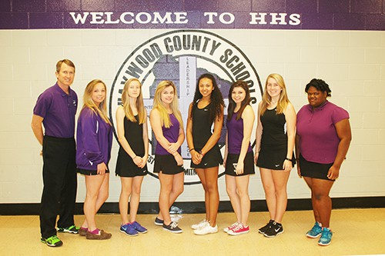
Members of the Haywood High School girls’ tennis team are Coach Stark Davis, Stewart Gillespie, Elizabeth Campbell, Gracie Glaser, Victoria Colbeck, Ellie Haynes, Sadie Sharpe and Candace Shaw.
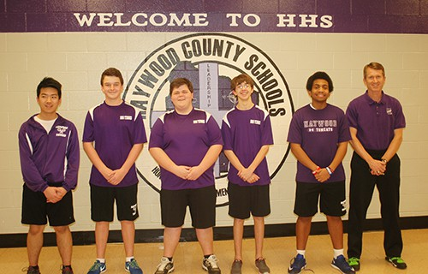
Members of the boys’ tennis team are Bendy Yuan-Zhao, Alex Sceals, Elliot Garrett, Everette Pettigrew, and Trevor Dancy with Coach Stark Davis.

