**2016 Haywood High School Tomcats Football Team**

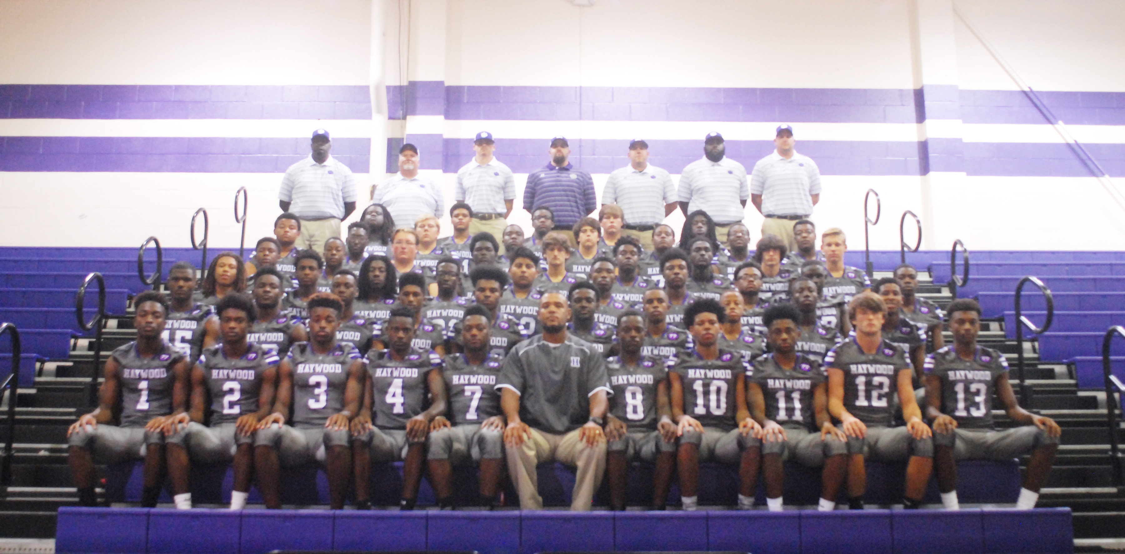

Members of the 2016 Tomcat football team are (1) Tristan Taylor, (2) Devondrius Hines, (3) Brandon Taylor, (4) Jai Evans, (7) Rashaun Tyus, (8) Tay Jones, (9) Andrew Stanley, (10) Taylor Shields, (11) Jakobe Swift, (12) Tillman McCrae, (13) Alex Taylor, (14) Jalin Turner, (15) Montavious Pugh, (16) Trevor Cunningham, (17) Detarion Baker, (18) Phelp Pearson, (19) Keeston Gause, (20) Jalin Hudson, (21) Darius Watkins, (22) Kalvin Carson, (23) D. J. Hawkins, (24) Demarius Pearson, (25) Xavier Walker, (26) Cortarrion Baker, (27) Nathan Sanderlin, (28) Kylan Clark, (29) Calen Johnson, (30) Devonte Biggs, (31) Decourtney Reed, (32) Joseph Sanchez, (33) Javaris Summerville, (34) Trotavious Green, (35) Patrick Currie, (36) Detyus Adams, (37) Bryan Taylor, (38) Anthony Mitchell, (39) D. J. Taylor, (40) Trondarious Rutherford, (50), Desi Moore, (51) Quay Jones, (52) Kedarious Woodfork, (53) Zach Esquivious, (54) Dylan Wilson, (55) Travion Bailey, (56) Kaleb Kutz, (58) Sam Banks (59) Larry B rooks, (60) Emmauel Beaird, (61) jamrius Brown, (62) Russ Cates, (64) Daddrick Maclin, (65) Jackson Pettigrew, (70) RaShawn Bradford, (71) Sherron Hines, (76) Isaiah Hess, (90) Dequote Seaberry, (91) Kerwin Young, (92) Xavier King, (93) Brent Moore, (94) Derrion Bell, and (95) Lemonte Middlebrooks.

Head Coach is Steve Hookfin. Assistant Coaches are Anthony Sawyer, Jarrod Kornegay, Chris Eubanks, D. J. Delk, Chris Brackeen, Rick Mason and Mike Snyder.