HHS 2017 Tomcat Football

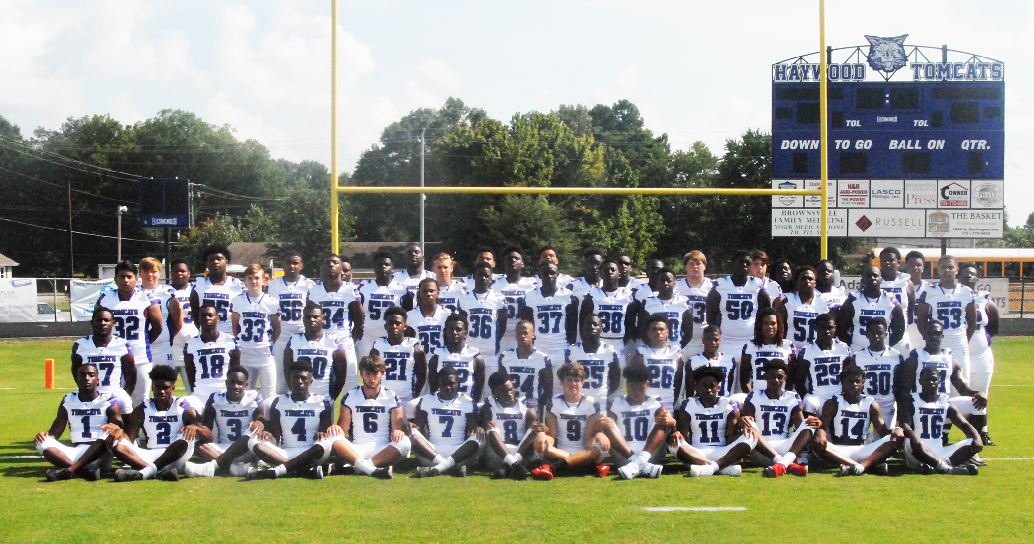
Members of the HHS 2017 Tomcat Football team are Tristan Taylor (1), Deyondrius Hines (2), Marquis Pugh (3), Derrion Williamson (4), Atlex Evans (7), Javarius Sommerville (8), Andrew Stanley (9), Taylor Shields (10), Jakobe Swift (11), Tillman McRae (12), Alex Taylor (13), Calen Johnson (14), Devonte Biggs (15), Trevor Cunningham (16), Detravious Baker (17), Phelp Pearson (18), Keiston Gause (19), Jalen Hudson (20), D. J. Taylor (21), Calvin Carson (22), D. J. Hawkins (23), Demarius Pearson (24), Xavier Walker (25), Tiriyon Wilks (26) Malik Turner (27), Khylan Clark (28), Travarius Baker (29), Treveon Banks (30), Decourtney Reed (31), Joseph Sanchez (32), Ethan Conatser (33), Tay Green (34), Andre Robertson (35), Marcus Jones (36), B. J. Taylor (37), Andrew Reed (38), Derion Love (39), Trondarius Rotherford (40), Cordarius Taylor (50), Travion Starks (51), Kendall Bond (52), Deon Jones (53), Zach Jeter (54), Jalen Clark (55), Iverson Hines (56), Dre Tyus (57), Sam Banks (58), Devin Jones (59), Rhyan Peet (60), Tradarius Franklin (61), Jamarius Brown (62), Tyrell Jenkins (63), Atlantis Cooper (64), Jackson Pettigrew (65), Dequortae Seaberry (70), Sherron Hines (71), Rahsawn Bradford (72), Martin Welch (73), Jacob Sanchez (74), Lamonte Middlebrooks (75), Kedariun Pirtle (76), Emmanuel Beard (90), Jerwin Young (91), Xavier King (92), Brent Moore (93), Derrion Bell (94), and Benard McDowell (95).
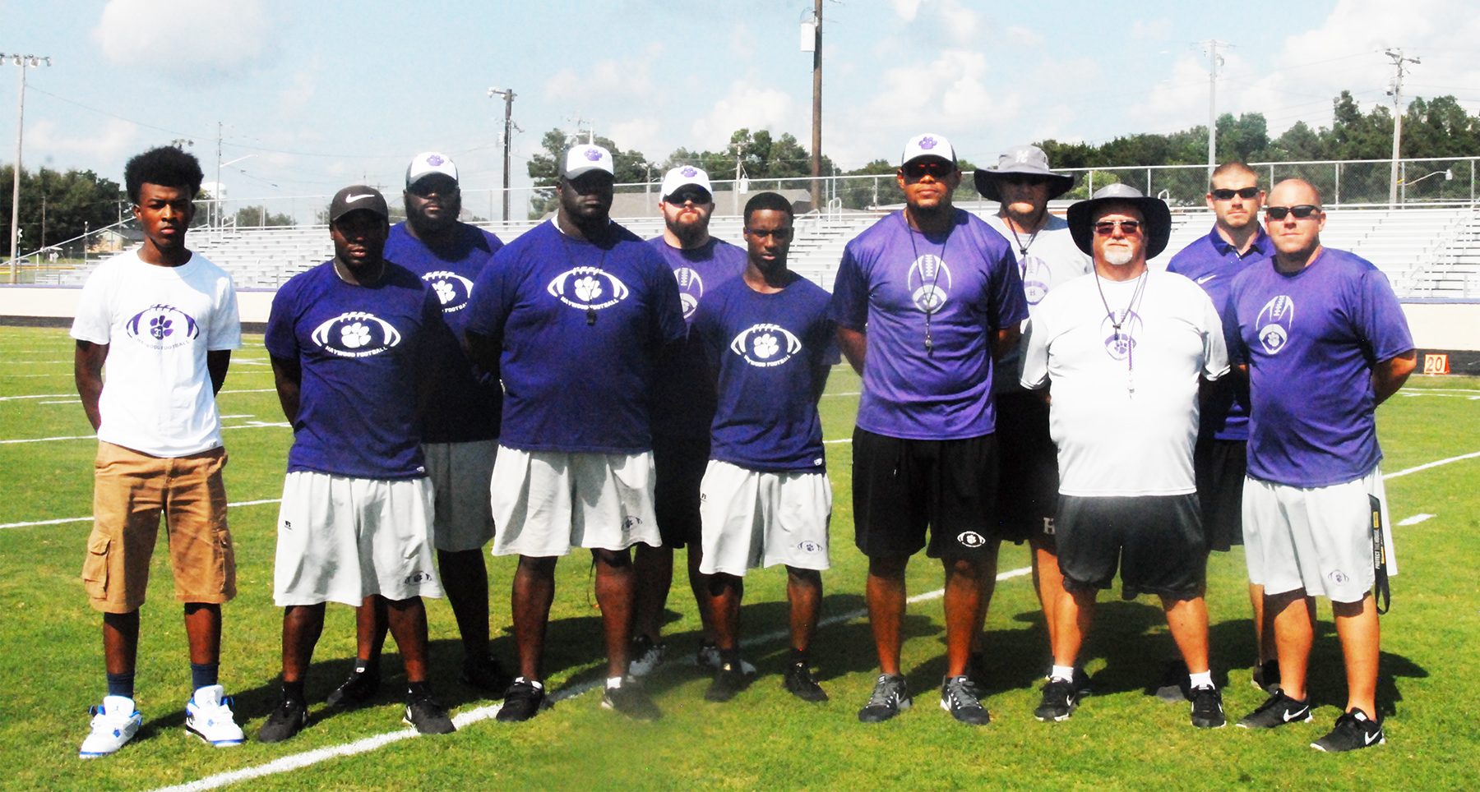

Coaches are Head Coach Steve Hookfin, and assistant coaches Anthony Sawyer, Chris Eubanks, Jarrod Kornegay, D. J. Delk, Chris Brackeen, Avandre Cross, Rick Mason, Mike Snyder, and Greg Luster.

