“Flying Tomcats”

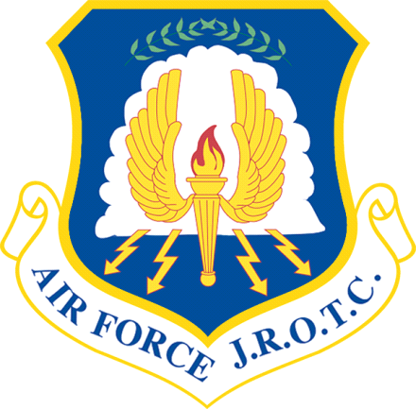

AFJROTC TN-944
Cadet Handbook
August 2018
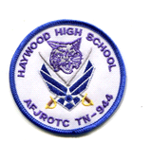
TN-944 AFJROTC
Haywood County High School
Brownsville, TN

FORWARD

The Tennessee 944 Air Force Junior ROTC Cadet Group was established at Haywood High School on July 1st, 1994, by agreement between Haywood County School District and the United States Air Force. Since that time it has enjoyed a rich heritage of training cadets of integrity, service, and excellence.

The Air Force Junior ROTC (AFJROTC) curriculum includes aerospace related academic instruction, leadership training, military drill training, and fitness training. The Aerospace Science Instructors are retired Air Force veterans with extensive backgrounds in professional academic education and Air Force military training, equipping them to be qualified to teach the AFJROTC curriculum.

The cadet group will be managed and operated by cadet commissioned and noncommissioned officers. From these leadership experiences cadet leaders learn firsthand what it takes to lead and manage a group of people through planned AFJROTC activities.

This Cadet Handbook contains policy guidance, requirements, and rules of conduct for AFJROTC cadets at Haywood High School. Each cadet is required to study this guide and will be held responsible for its contents. Remember that it is only a guide and not a substitute for initiative, common sense, and good judgment.

Congratulations to each of you on your decision to enroll in the AFJROTC program. We wish you success and personal satisfaction as members of Haywood High School’s TN-944 AFJROTC Cadet Group.

s/
Myron O. Stamps, Lt Col, USAF (Ret)
Senior Aerospace Instructor

CONTACT INFORMATION

Senior Aerospace Science Instructor (SASI):

Lt Colonel (Retired) Myron O. Stamps
- 731-772- 1845 (Work)
- myron.stamps@hcsk12.net

Aerospace Science Instructors (ASI):

Major (Retired) Delois Dailey
- 731-772- 1845 (Work)
- delois.dailey@hcsk12.net

MSgt (Retired) John Parker
- 731-772- 1845 (Work)
- john.parker@hcsk12.net

“Building tomorrow’s leaders today”

TN – 944 CADET GUIDE
TABLE OF CONTENTS

Chapter Page
- Mission and Objectives of the AFJROTC Program 5
- Admission, Transfer and Responsibilities of Students 6
- Conduct and Military Courtesy 9
- Cadet Honor Code 11
- Personal appearance of cadets 15
- Wearing the uniform 19
- Clothing and equipment account 23
- Saluting/Pledge of Allegiance/National Anthem rules 26
- Classroom Policy 28
- Curriculum 30
- Co-Curricular activities 34
- Promotion of cadets 37
- Special Safety Policies 39
- Organization of the TN-944 AFJROTC group 40
- Unit Detail listing 41
- Job descriptions 44
- Insignia, badges, and patches 51
- Certificates of completion and training 68
- Staff Meeting Procedures 70
- Open door policy rules 72
- Fall Welcome Parent/Uniform Letter 73
- AFJROTC Physical Health Screening Questionnaire 75
- Glossary 76
- Uniform Appendix 78

CHAPTER ONE
MISSION AND OBJECTIVES OF THE AFJROTC PROGRAM

- AFJROTC Mission: Develop citizens of character dedicated to serving their nation and community.

- The objectives of AFJROTC:
  - Educate and train high school cadets in citizenship.
  - Promote community service.
  - Instill responsibility, character, and self-discipline.
  - Provide instruction in air and space fundamentals.

- AFJROTC cadets should develop:
  - The Air Force Core Values of:
- Integrity first.
- Service before self.
- Excellence in all we do.
  - An appreciation of the understanding of the basic elements of national security.
  - Respect for and an understanding of the need for constituted authority in a democratic society.
  - Patriotism and an understanding of their personal obligation to contribute toward national security.
  - Habits of orderliness and precision.
  - A high degree of personal honor, self-reliance, and leadership.
  - Broad-based knowledge of the aerospace age and fundamental aerospace doctrine.
  - Basic military skills.
  - Knowledge of and an appreciation for the traditions of the Air Force.
  - An appreciation for the Air Force or other military service as a career.
  - A new sense of self discipline, self esteem, and confidence.

CHAPTER TWO
ADMISSION, TRANSFER, AND RESPONSIBILITIES OF STUDENTS
1. Eligibility for admission into the Air Force Junior Reserve Officer Training Corps (AFJROTC) program is determined by the Jeanne M. Holm Center for Officer Accessions and Citizen Development in accordance with AFJROTC Instruction 36-2001. The goal is a proportionate representation of the entire student body. To be eligible to participate and continue in AFJROTC, students must be:

a. Enrolled in and attending a regular course of instruction in the school, school with cross town agreement, or home-schooled student. Cross town students may participate if both school principals agree to the participation in writing and the course (transcript) counts for the student’s credit toward graduation. Home school students may participate with the permission of the principal and AFJROTC instructor.

b. Selected by the AFJROTC instructor in coordination with the principal (or a designated representative) to ensure enrolled students meet acceptable standards.

c. In grades 9 through 12.

d. A citizen or national of the United States or an alien admitted for permanent residence, or a Foreign Cadet (see 2. below).

e. Physically fit. Students must be qualified, approved, or capable to participate in the school’s standard physical education program. NOTE: Individual accommodations will be made as appropriate for disabled students.

2. Foreign Cadets are those who do not meet the citizenship requirements. Foreign Cadets are eligible to fully participate in Haywood High School’s AFJROTC program and must meet all standards of the program.

3. Disenrollment. As a rule, disenrollment from AFJROTC is approved by the principal in coordination with the Senior Aerospace Science Instructor. Disenrollment should be a last resort, preceded by substantiated documentation and corrective counseling, to maintain the morale and discipline of the unit. It is impossible to list every possible breach of discipline that could lead to the loss of a leadership position/rank and/or removal from. The SASIS/ASI will weigh each case carefully before reaching a decision. However the following actions will always lead to the removal from the AFJROTC program:

- Inaptitude or indifference to training
- Disciplinary reasons (Two or more suspensions during any semester)
- Purchase, possession, use or sale of alcohol or illegal drugs
- Any other reason deemed appropriate by the principal and AFJROTC instructors
- Failure to maintain acceptable standards and wear the uniform. Three (3) unexcused uniform wear violations in a semester will result in failure of the class.

4. Reserve Cadets. A Reserve Cadet is a student who is in a 4x4 schedule and enrolled in Fall Semester or Spring Semester of the school year, and is not participating in AFJROTC course the current semester. Examples, if enrolled in the course in the Fall Semester (August – December) you can be a Reserve Cadet in the Spring Semester, and if you enrolled in the Spring Semester (January – May) you can be a Reserve Cadet. This applies to the Cadets that want to continue contributing to TN-944 AFJROTC during the entire school year.

4.1.1 If you are in 1st Semester or 2nd Semester RESERVE STATUS you are subject to the same conduct and behavior standards as IF you were in the classroom i.e.…no Bus Suspensions, In-School Suspensions, Out Of School Suspensions or derogatory comments from any teachers, staff or administrators employed by Haywood County School District, and must be passing all classes. Students meeting these criteria may be designated, with SASI concurrence, as a Reserve Cadet. Reserve Cadets may participate in all AFJROTC activities (CIA trips, community service, all drill teams, Honor Guard, and POW/MIA teams.). This is an incentive for your annual commitment and participation in the program. Additionally, Reserve Cadets that have been issue ABUs or hold a leadership position will have to participate in at least one uniform inspection per month.

4.1.2 Time in reserve status does not count towards the Certificate of Completion, nor does Reserve Cadet status count toward minimum unit enrollment or unit funding. Reserve Cadets may retain their uniform for the entire academic year.

DID YOU KNOW?
1. There is no military service obligation for participating in AFJROTC.

2. AFJROTC cadets have an opportunity to earn scholarships.

3. AFJROTC cadets may have an advantage when competing for appointments to the U.S. Air Force Academy and the other service academies.

4. Cadets who complete 3 years of JROTC and enlist in the military may qualify for higher pay.

5. Membership in the AFJROTC unit is open to most high school students, but cadets must maintain a “C” average in AFJROTC to stay in the program or request a waiver from the SASI.

6. AFJROTC courses carry the same credit as other elective subjects and two years of JROTC credit will waive 1.0 credit of Physical Education.

7. Cadets earn medals, ribbons, trophies, plaques and other awards based on scholarship, military bearing, appearance, and community service.

8. AFJROTC uniforms, insignia, medals, ribbons and textbooks are provided at no cost (provided they are returned in good condition).

9. Members of the Drill Team, Color Guard and Fitness teams travel to compete against other units.

10. Each summer outstanding cadets have the opportunity to participate in a Cadet Leadership Course.

11. Each semester cadets go on field trips to military bases and other points of interest.

12. Each winter/spring cadets must attend the formal Military Ball and Awards Banquet.

13. Cadets gain leadership experience and self-confidence by working in leadership positions in the cadet corps.

14. One day each week cadets participate in Physical Training (PT), which includes warm up exercises, running, and various sporting activities.

CHAPTER THREE
CONDUCT AND MILITARY COURTESY

- GENERAL: Cadets are expected to observe correct military conduct at all times. Such behavior will reflect credit upon themselves, their parents, the Cadet Group, Haywood High School, and the United States Air Force.

- CLASSROOM/ASSEMBLY PROCEDURES:
a. At the beginning of the class, the Flight Commander will call the class to stand at attention. The Flight Sergeant will then command: “Element 1, 2, 3, 4…Report” to each Element, one at a time. Each Element Leader, will report to the Flight Commander the name of any cadet who is absent or tardy by saluting and stating, “Cadet(s) (last name) is absent Sir/Ma’am.” If no cadets were absent, the element leader would state “All present or accounted for Sir/Ma’am.” The Flight Sergeant will then return the salute. When all element leaders have reported, the Flight Sergeant will report to the Flight Commander, stating the results of the attendance. The Flight Commander will then report to the SASI/ASI “All cadets accounted for, ready for instruction. If the Flight Commander or Flight Sergeant is absent, the next highest ranking cadets will take on these responsibilities. If any element leader is absent, the alternant element leader will take his or her place. (Promptness is an objective of the program and cadets are expected to be in formation, i.e. by their desk, before the late bell.)
b. The Flight Commander will then lead the class in reciting the core values drill, or any other commands as given by the SASI/ASI. Then the Flight Commander will give the command: “Take Seats.” and read the daily announcements to the class.
c. In the event the SASI/ASI is delayed, the Flight Commander (or senior ranking cadet) will begin the reporting process, and pass on the report to the SASI/ASI when they arrive, leading the class to begin studying the materials for that day’s instruction.
d. Cadets who enter the classroom after the tardy bell has rung will give their admittance slip to the instructor, and follow the instructor’s direction for joining that day’s class.

3. CLASSROOM RULES:
(1) Integrity First: No lying, no cheating, no stealing.
(2) Service Before Self: Respect others, serve others.
(3) Excellence In All We Do: Excellence always.
(4) Follow the school grooming standards and dress code, and the AFJROTC grooming standards and dress code and uniform days.
(5) Do not chew gum in the formation.
(6) Comply with instructions given to you by the instructors given to you or the cadet who has been placed in charge by the instructors.
(7) Bring to class the materials required for that class (always have paper and pencil or pen).
(8) Cell phones and other electronic devices are not allowed to be used in class, and if used will be surrendered to the instructor in accordance with school policy.
(9) Be attentive when someone else is speaking (respect others).
(10) Do not sleep in class. If you cannot stay awake, standup and move to the rear of the classroom.
(11) Let the instructor know if you are ill.
(12) No public displays of affection (PDA) per the school policy.

4. MILITARY COURTESY: Cadets should say “Yes Sir/Ma’am” or “No Sir/Ma’am,” to officer instructors, teachers, adults, and, in appropriate cadet activities, to cadet officers. Cadets should say “Yes Sergeant” to NCO instructors and, in appropriate cadet activities, to cadet NCOs. Such responses reflect long-established military courtesies that will soon become a habit, though sometimes difficult at first. The instructors intend to enforce strict military courtesy throughout the course of instruction, during both classroom and drill instruction periods. Saluting will be covered in more detail in Chapter 8.

5. LEARN TO THINK BEFORE SPEAKING: Cadets should work hard to become better listeners, striving to understand instructions for themselves. Cadets should learn to rely on their own abilities, speaking and asking questions after trying to resolve matters in their own minds.

CHAPTER FOUR
CORPS OF CADETS HONOR CODE

1. We can take a lesson from all the services academics whose young men and women adhere to strict honor code. It is: “ I will not lie, cheat, or steal – nor tolerate those who do.” Though this is a seemingly tough code to live by, it is not so tough in reality when you consider that by putting on the uniform you are putting on the public trust as well. Although, as a junior cadet, you are not committed to the Air Force, you are still expected to try to bring honor to yourself and your school. The best way to do that is to guard your integrity as the most precious asset you have. Do not lie, cheat, or steal or allow anyone else to, and you will always have the trust you will need to succeed. The honor code is mandatory at the service academics. We in TN-944 strongly encourage you to follow this code. Our school and unit standards intersect with this code. Always remember that the subject of honor is very important to us.

2. By definition, cheating is taking unfair advantage of a situation or of fellow classmates. This may be done in order to obtain higher grades, better scholarship opportunities, an academic or leadership award, a better grade point average, or some other tangible gain. Cheating is usually, but not always, accomplished by using or copying from another person’s work, or purposely not following instructions, and often takes the form of some last minute action that is done without thinking.

3. Every human has the tendency to cheat, therefore every effort must be made to not fall into this bad behavior. There are many ways to cheat. We will consider cheating from the point of view of whether an improper gain has been made. If an opportunity presents itself which, if taken advantage of, allows you to gain unfairly over your classmate; that is cheating.

4. CHEATING IS NOT PERMITTED IN AFJORTC OR AT HAYWOOD HIGH SCHOOL. It is important that each cadet understands this basic requirement and makes every effort to follow it. Cadets who are caught cheating identify themselves as people not worthy of holding cadet rank, or being promoted, or receiving recommendations, scholarships, awards or any other special recognition in the future. The following other actions can be expected of those found cheating:

a. The case may be presented to the senior cadet staff who may act as the reviewing board to make a recommendation of punishment to the SASI. Upon receiving possible recommendations of the senior cadet staff and the other instructors, the SASI will be the final authority to approve and issue punishments for honor violations.
b. The guilty cadet will receive a zero on the assignment or test.
c. The cadet’s parents may be notified of the cheating incident, and the cadet and family will be given the opportunity to make any statements they deem relevant to the outcome of the case.
d. A record of the incident may be made in your Permanent Scholastic Record, which could preclude receiving other scholastic awards or introduction into the National Honor Society or Kitty Hawk Society.

5. Individuals who either passively (but knowingly) or purposely allow others to copy their work are just as guilty of cheating as the active cheater is. They are willing participants and have endorsed by their action an act of dishonesty. They will be dealt with in the same process as the active cheater.

6. While individual instances of cheating will be dealt with on an individual basis, these guidelines are intended to inform, in advance, all cadets of the seriousness with which such activities are viewed by Haywood AFJROTC instructors.

7. Cadets who find theses guidelines offensive or who believe them to be impossible to follow should talk with an AFJROTC instructor immediately about leaving the corps.

8. ANTI-DRUG PROGRAM: DRUGS ARE NOT TOLORATED! Anyone possessing drugs will be handled under the Haywood Board of Education’s Zero Tolerance Policy. Students who know of anyone with drugs or weapons should report them to a JROTC instructor immediately. Though your name is never used, if the suspect if found to have an illegal substances or weapons you may receive a monetary reward through Haywood High School.

9. Honor and other discipline cases should be reviewed by the senior cadet staff for recommendations to the SASI who is the final unit disciplinary authority.

THINGS NEVER TO BE SAID

I can’t…… (Yes you can!)

I forgot…… (Use a planner or write a note!)

I don’t know……. (Ask someone or do some research!)

It’s not my fault…… (Accept responsibility for your actions!)

Who is going to look out for you when your current support system no longer exists?

Stop making excuses and start making good decisions. Plan ahead, take action, and be an advocate for your own success.

Decisions, Consequences, Responsibility/Accountability!
THE TN-944 COMMANDMENTS

- Thou Shalt “Lead By Example.”

- Thou Shalt Not Whine.

- Thou Shalt Make No Excuses.

- Thou Shalt Not use The Terms “Yeah” and “Nah.”

- Thou Shalt Not Walk or Stand with Thy Hands In Thy Pockets when in uniform.

- Thou Shalt give their best effort at all times.

- Thou Shalt Not Complain About the Other Commandments.

CHAPTER FIVE
PERSONAL APPEARANCE AND GROOMING OF CADETS

1. Appearance and Grooming. (AFJROTC Guide, 3.1)
When a cadet wears the uniform, he/she is responsible for presenting a neat, clean, and professional military image. Appearance and grooming standards help cadets present the image of disciplined cadets who can be relied upon to do the job they are called on to do. A professional military image has no room for the extreme, the unusual, or the faddish. The standards for wearing the uniform consist of four elements: neatness, cleanliness, safety, and military image. The first three are absolute, objective criteria for the efficiency, health, and well-being of the force. The fourth standard, military image is also a very important aspect of military appearance. People, both military and civilian, draw conclusions as to the military effectiveness of the Air Force by how they perceive those in uniform.

Each AFJROTC cadet must wear the uniform properly. The importance of this requirement cannot be over-emphasized because the uniform, except for the insignia, is the same uniform worn by the United States Air Force. AFJROTC cadets will wear the standard service uniform prescribed for active duty personnel in AFI 36-2903, Dress and Personal Appearance of Air Force Personnel. The fitting standards, wearing instructions, and personal grooming standards also prescribed in AFI 36-2903 are applicable. The USAF, as a professional military organization, is known worldwide and has no equal. The uniform you will wear is a symbol of reputation. Wear it Proudly!

Combination 1: Service dress uniform (Service Coat, tie or tab with ribbons)
Combination 2: Short/Long sleeve shirt and tie or tab with ribbons.
Combination 3: Short sleeve shirt, open collar and ribbons.
Combination 4: Short sleeve shirt, open collar, no ribbons.
Combination 5: PT gear
Combination 6: Group T-Shirt or Hoodie
Combination 7: ABU
.

3.1.1. Special Uniform and Appearance Rules. Here are some additional guidelines about uniform and appearance.

3.1.1.1. Jewelry. While in uniform, you may wear a wristwatch and rings, but no more than three rings at any one time. You may wear one bracelet if it is neat and conservative. However, the bracelet must not detract from military image, must not be wider than one-half inch, and must not subject anyone to potential injury. You may not wear ornaments on your head or around your neck. Thumb rings are not allowed in uniform. Colored bracelets that support a cause are also not allowed.

Female cadets in uniform may wear earrings if the earrings are conservative and kept within sensible limits. For example, you may wear one small spherical (diamond, gold, white pearl, or silver) pierced or clip earring on each earlobe. The earring worn in each earlobe must match. Earrings should fit tightly without extending below the earlobes, unless they are clip earrings. Male cadets in uniform may not wear earrings.

3.1.1.2. Eyeglasses or Sunglasses. If you wear glasses, they must not have any ornaments on the frames or lenses. Eyeglass lenses that are conservative, clear, slightly tinted, or have photosensitive lenses may be worn in uniform while indoors or while in military formation. When outdoors and in uniform, sunglasses and eyeglasses must have lenses and frames that are conservative; faddish or mirrored lenses are prohibited. Sunglasses are not allowed while in a military formation. Neither eyeglasses nor sunglasses can be worn around the neck while in uniform.

3.1.1.3. Tattoos or Brands. Whether you are in or out of uniform, tattoos or brands anywhere on the body are not allowed if they are obscene or if they advocate sexual, racial, ethnic, or religious discrimination. Tattoos or brands that might harm good order and discipline or bring discredit upon the Air Force are also barred, whether you are in or out of uniform.

Excessive tattoos or brands, even though they do not violate the prohibitions in the above paragraph, will not be exposed or visible (including visible through the uniform) while in uniform. Excessive is defined as any tattoo or brands that exceed one-quarter of the exposed body part, and those above the collarbone and readily visible when wearing an open collar uniform.

The SASI may exercise discretion if a new cadet arrives with a tattoo that may not be in full compliance with the above guidance. The tattoo may be covered up with a skin-colored bandage while in uniform and still participate in the program. However, tattoos and brands should be discouraged. The cadet should be counseled on the fact that tattoos and brands may preclude him or her from serving in the military.

3.1.1.4. Body Piercing. Cadets in uniform are not allowed to attach or display objects, articles, jewelry, or ornamentation to or through the ear, nose, tongue, or any exposed body part (including anything that might be visible through the uniform). Female cadets in uniform, however, are allowed to wear conservative earrings, pierced or clip style, in their earlobes. (Earrings may be worn if they are small, conservative, pearl white, gold, or silver, diamond, diamond looking and spherical. Clip-ons must fit tightly and may not extend below the earlobe. Only one earring per ear is allowed. Multiple piercings will not have earrings in the ear while in uniform.) Male cadets in uniform may not wear earrings or any other type of facial piercings.
. Cadets may not cover any of these articles with make-up, band aids, or wearing clear post pins to hide body piercings.

3.1.1.5. Back Packs. Cadets may wear a back pack on the left shoulder or both shoulders (not to interfere with rendering the proper salute).

3.1.1.6. Wear/use of an earpiece, any blue tooth technology or headphones, while in uniform, indoors or outdoors, is prohibited, unless specifically authorized for the execution of official duties. Exception: Headphones and earphones [iPods, MP3-type players, etc.] are authorized during travel on public transportation i.e., bus, train or air travel.

2. Specific Female Cadet Grooming Guidelines. (From AFJROTC Guide, 3.2)
3.2.1. Hair. There is no minimum hair length, to a maximum bulk of 3 ½ inches from scalp and allows proper wear of headgear. Hair will end above the bottom edge of collar and will not extend below an invisible line drawn parallel to the ground, both front to back and side to side. Bangs, or side-swiped hair will not touch either eyebrow, to include an invisible line drawn across eyebrows and parallel to the ground. See Figure 3.4. When in doubt, assess correct length of hair with Airman standing in the position of attention. Exception: While wearing the Physical Training Uniform (PTU), long hair will be secured but may have loose ends and may extend below the bottom edge of the collar.

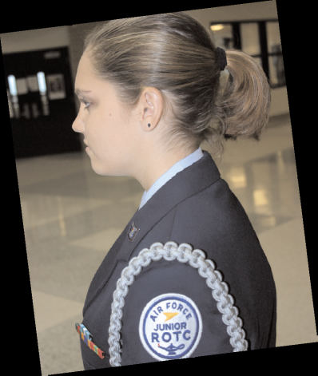

Hair will not contain excessive amount of grooming aids, touch eyebrows. Hair color/ highlights/frosting (must not be faddish). Examples of natural looking for human beings: Blonde/Brunette/ Red/Black/Grey. No shaved heads or flat-top hairstyles for women. Micro-braids and cornrows are authorized for women. (Hair ornaments, such as ribbons, will not be worn. Hairnets are not authorized. Pigtails, and any other hairstyles that allow the hair to extend below the bottom of the collar of the over-blouse or jacket are not authorized. Hair will be groomed so that it does not touch the eyebrows and will not cover any portion of the face. However, Afro, natural, bouffant, and similar styles are authorized except those with excessive fullness or extreme height—over three inches. Ponytails are allowable as long as they do not extend below the bottom of the collar of the blue shirt and do not prohibit proper wear of the hat.)

EXCEPTION: Hair may be visible in front of women's flight cap. However, long hair will be secured with no loose ends.

3.2.1.1. Hair color, highlights, lowlights, and frosting will not be faddish or extreme and will be natural looking hair color, similar to the individual’s hair color (e.g. black, brunette, blond, natural red, and grey).

3.2.1.2. Hair accessories. If worn, black hair accessories (e.g., fabric scrunchies, hairpins, combs, clips, headbands, elastic bands, barrettes, etc.) are authorized regardless of hair color. Headbands or fabric scrunchies will not exceed one-inch in width. Ornaments are not authorized (i.e., ribbons, beads, jeweled pins).

3.2.1.3. Locs, braids, twists, micro-braids, french braids, dutch braids and cornrows are authorized. Locs are defined as portions of hair that have been intentionally or unintentionally fused together to form a loc or locs. A braid or twist is two or more portions of interwoven hair. If adding additional hair, it must be a natural-looking color, similar to the individual's hair color. It must be conservative (moderate, being within reasonable limits; not excessive or extreme) and not present a faddish appearance. Hair must not exceed bulk and length standards and must not extend below the bottom of the collar (see figure 3.2). Headgear must fit properly.

3.2.1.2. All locs braids/twists, when worn will be of uniform dimension, no wider than one inch, with natural spacing between the locs, braids/twists and must be tightly interwoven to present a neat, professional and well-groomed appearance. When worn, multiple locs/braids shall be of uniform dimension, small in diameter (approx. ¼ inches), show no more than ¼ inch of scalp between the braids and must be tightly fused/interwoven to present a neat, professional appearance. A loc, braid/twist must continue to the end of the hair without design and following the contour of the head, and may be worn loose or in a secured style within hair standards in paragraph 7.9.3 above. Exception: Micro-braids or twists are not required to continue to the end of the hair.

3. Specific Male Cadet Grooming Guidelines. (From AFJROTC Guide, 3.3)

3.3.1. Hair. Keep your hair clean, neat, and trimmed. It must not contain large amounts of grooming aids such as greasy creams, oils, and sprays that remain visible in the hair. When your hair is groomed, it should not touch your ears or eyebrows, and only the closely cut or shaved hair on the back of your neck should touch the collar.

Your hair should not exceed 1 1⁄4 inch in bulk regardless of the length. Bulk is the distance that the hair projects from the scalp when groomed (as opposed to length of the hair). The bulk and length of your hair must not interfere with wearing any Air Force headgear properly, and it must not protrude below the front band of the headgear. Your hair must have a tapered appearance on both sides and back, both with and without headgear. A tapered appearance means that, when viewed from any angle, the outline of the hair on the side and back will generally match the shape of the skull, curving inward to the end point.

Your hair may not contain or have attached to it any visible foreign items. If you dye your hair, it should look natural. You may not dye your hair an unusual color or one that contrasts with your natural coloring. You may have sideburns if they are neatly trimmed and tapered in the same manner as your haircut. Sideburns must be straight and of even width (not flared) and end in a clean-shaven horizontal line. They may not extend below the lowest part of the outer ear opening. No extreme of faddish hair styles are allowed. Hair may not protrude below the front band of properly worn headgear. (Hair will be neatly cut, clean, trimmed, and present a groomed appearance. Hair will be groomed to follow the contours of the head and will not touch the ears or collar. Hair in the front will be groomed so that is does not fall below the eye brows and will not protrude below the band of properly worn headgear. Mohawks, ducktails, lines or initials/lettering shaved into head, and “Mr. T’s” are not authorized, nor are other bizarre hairstyles, including partially shaved heads. The face will be clean-shaven except the mustaches are permitted. If worn, mustaches will be neatly trimmed, must not extend downward beyond the lip-line of the upper lip and may not extend sideways beyond a vertical line drawn upward from the corner of the mouth. Beards or goatees are not permitted.)

CHAPTER SIX
WEARING THE UNIFORM

From the AFJROTC Guide:

Introduction. AFJROTC cadets wear the same basic uniform as the active duty Air Force, and they should be expected to honor and wear the uniform properly and with pride. This chapter provides the latest guidance and clarification on AFJROTC uniform wear.

1. ACCOUTREMENTS (GENERAL)

1.1. Insignia Placement. Insignia on the AFJROTC uniform will be worn according to the figures contained in this guide. Holm Center/JROS is the review/approval authority for waivers and for situations not specifically addressed by this guide.

    - Authorized Air Force JROTC Badges and Insignia. Hap Arnold insignia is authorized for wear on the service cap for enlisted/officer and pins removed.

    - - Cadet Male Headgear – Hap Arnold insignia is authorized for wear on the service cap. Officer hat pin has been replaced with officer rank. Note: Enlisted ranks will have no insignia on the flight cap.

    - Cadet Female Headgear – Hap Arnold insignia is authored for wear on the service cap. Officer hat pin has been replaced with officer rank. Note: Enlisted ranks will have no insignia on the flight cap.

    - Cadet ABU Headgear – Officers will wear rank insignia on the ABU cap. Note: Enlisted ranks will have no insignia on the ABU cap.

1.2. Badges.

1.2.1. Ground School Badge. Awarded for successful completion of the AFJROTC aviation honors ground school curriculum or successful completion of another aviation ground school program prescribed by the FAA. To order the badge go to WINGS | Logistics | Create Display Orders.

1.2.2. Flight Solo Badge. Awarded to any cadet possessing a solo flight certificate signed by a FAA certified flight instructor for either powered or non-powered aircraft. Email HQ-Logistics@afjrotc.com a copy of the Cadets Flight Solo Certificate, and then go to WINGS | Logistics | Create Display Orders and order the Flight Solo Badge.

1.2.3. Pilot Certificate Badge. Awarded to any cadet who possesses a valid FAA pilot’s certificate for either powered or non-powered aircraft. Email HQ-Logistics@afjrotc.com a copy of the Cadets Flight Solo Certificate, and then go to WINGS | Logistics | Create Display Orders and order the Pilot Certificate Badge.
.

1.2.4. Awareness Presentation Team Badge. Awarded for participation on an Awareness Presentation Team. Criteria for becoming a member of the team should be published in the Cadet Guide or the Unit Operating Instructions. Go to WINGS | Logistics | Create Display Orders and order the Awareness Presentation Team Badge.

1.2.5. Kitty Hawk Air Society Badge. Awarded to cadets who are members of the Kitty Hawk Air Society. The unit’s Kitty Hawk charter should spell out the requirements for entry into the society. Go to WINGS | Logistics | Create Display Orders and order the Kitty Hawk Air Society Badge.

1.2.6. Academy Modeling of Aeronautics (AMA) Wings. Awarded to cadets who are members of a local AMA chartered model airplane club. Contact the AMA to obtain badge for qualifying cadets.

1.2.7. Distinguished AFJROTC Cadet Badge. This annual award consists of a certificate and the Distinguished AFJROTC Cadet badge. The award recognizes one outstanding second-year cadet (third-year cadet in a 4-year program) selected at the end of each school year. This allows the recipient to wear the award their final year in the AFJROTC program. The recipient must be of high moral character, demonstrate positive personal attributes, display outstanding military potential, and maintain consistent academic and military excellence.

The SASI, in coordination with the ASI and with the concurrence of the principal, selects the recipient of this award. The Holm Center Form 308, Certificate of Recognition, is located in WINGS | Published Files | Directory | Certificates folder. The certificate is used to present with the badge. The unit must purchase the badge from a vendor. The recipient should hold the following awards prior to selection:

  - Leadership Ribbon
  - Achievement Ribbon
  - Superior Performance Ribbon
  - Academic Ribbon
  - Cocurricular Activities Leadership Ribbon
  - Service Ribbon

1.2.8. Aerospace Education Foundation (AEF) Academic Cadet Badge. Awarded to rising Junior and Senior cadets for academic excellence as signified by attaining an overall 3.3 grade point average with no grade below “C” on their transcript. The individuals must be recommended by the SASI. Go to WINGS | Logistics | Create Display Orders and order the AEF Badge.

1.2.9. Model Rocketry Badge. Awarded to cadets who have fulfilled model rocketry program requirements. Program requirements are listed in the Model Rocketry Handbook available in WINGS | Published Files | Directory | JROTC | Instruction and Guides | Model Rocketry Handbook. OPR: Holm Center/JROSL.

1.2.10. Other Badges. Wearing badges from other services beyond their intended purpose, badges from the regular Air Force, or other organizations on the AFJROTC uniform is prohibited. Example: Unit cannot designate Army Signal Corps or Infantry badges to signify membership in the unit color guard or drill team. However, badges earned by cadets enrolled in a sister service JROTC program may be worn on the AFJROTC uniform in the location specified by the sister service. The AFJROTC badge location will always take precedence over the sister service badge.

1.2.11. Marksmanship Awards. Marksmanship competition awards/badges may be worn on the AFJROTC uniform. Males wear the badges under the ribbons on the left pocket flap of the light blue shirt or below the ribbons on the service dress uniform. Females wear the badges above the ribbons on both uniforms.

1.3. AFJROTC Shoulder Patch. Wear of the AFJROTC official shoulder patch is mandatory on all uniforms except the raincoat, overcoat, and all-weather coat. Cadets enrolled in Civil Air Patrol (CAP) and AFJROTC who use the same uniform for both activities may wear the CAP wing patch on the right shoulder and the AFJROTC patch on the left shoulder with the AFJROTC shoulder patch taking precedence.

1.4. Shoulder Cords. Cadets are authorized to wear one shoulder cord on the left shoulder. Wear the shoulder cord only on light blue shirt and the service dress coat. The SASI will designate criteria on who may wear shoulder cords. Colors to denote different honors or leadership positions may be used. Criteria and shoulder cord colors should be described in the Cadet Guide or Unit Operating Instructions. On the service dress coat, cords should be pinned to the shoulder with the pin hidden beneath the cord.

The following is a list authorized shoulder cords and their colors that can be worn on the left shoulder of long or short sleeve shirt and the service coat:

Note: The following are drill team shoulder cords that will be awarded to team members after completing one school year of successfully competing in drill meets and is awarded the following year upon returning to the drill team, (nickel tip is for team commander):

Black/White Shoulder Cord – Armed Drill Team
Black Shoulder Cord –Armed Exhibition Team
Silver Hap Arnold Shoulder Cord – Color Guard
Silver Hap Arnold Shoulder Cord – Honor Guard
Green/Gold Shoulder Cord – CLC Graduate
Purple/Black Shoulder Cord – Saber Team
Navy Blue Shoulder Cord – UnArmed Exhibition Team
Navy Blue/White Shoulder Cord – UnArmed Drill Team

Note: The following designated unit position shoulder cords that will be awarded to members currently fulfilling the following position(s):

Silver/Silver Metallic, with two braids – Corp Commander
Orange Shoulder Cord – Inspector General
Dark Gray Shoulder Cord – Group Senior Enlisted Advisor (SEA)
Dark Gold Shoulder Cord – Logistics Commander
Purple Shoulder Cord – Flight Commander
Purple/White Shoulder Cord – Squadron Commander

1.5. Shoulder Tabs. Shoulder tabs are cloth arches denoting participation in a JROTC activity. Cadets are authorized to wear one shoulder tab on the right shoulder of the service dress coat, lightweight blue jacket and the light blue shirt, centered between the unit patch and the shoulder seam. Tabs will have the name of the activity on them (e.g., drill team, saber team, honor guard, etc.). If no unit patch is worn, tab should be worn 1 inch below the shoulder seam. If a unit patch is worn, shoulder tab should be centered between the unit patch and the shoulder seam. Only cloth shoulder tabs are authorized. Shoulder tabs are optional. The SASI will designate which activities will be denoted by shoulder tabs and set the criteria for each.

CHAPTER SEVEN
CLOTHING AND EQUIPMENT ACCOUNT

1. Protecting government property is each cadet’s respnsibility. All uniform items (with the exception of shoes and socks), AFJROTC textbooks, computers, plotters, charts, etc., are equipment items loaned to you by the Air Force. Other items of equipment belong to or are the respnsibility of Haywood High School. Each item of the uniform and of equipment must be accounted for at all times.

2. At the time you are issued your uniform and items of equipment you will be required to sign a Custody Receipt Form and place your initials on each line for individual items of uniform and equipment issued. Each item then becomes your personal responsibility. If you lose an item, or willfully or negligenty destroy it, you will be required to pay for it. At the time of issue of uniforms and equipment you will be advised of the cost of each item issued. The cost of replacement, however, will be the cost that is in effect when the account is scheduled to be cleared.

3. One complete uniform with all accessories and insignia is issued to each cadet. It is most important that each cadet understand that all items of uniform or equipment (with the exception of shoes and socks) must be returned of paid for before the end of the semester/school year. Uniforms must be returned cleaned, pressed, and on hangers or they will not be accepted by the MPC. No AFJROTC Certificate of Training, Certificate of Completion, nor diploma will be awarded until all uniform and equipment items have been turned in. In addition, a financial obligation will be incurred which will disallow graduation, registration, or transfer of credit until satisfied.

4. To preclude unnecessary expense to the cadet and/or delay of receipt of grades or diploma, and to provide for efficient turn-in of uniforms and equipment, the following suggestions are offered:

- Do not leave uniform items in unlocked lockers or unatended in other places at school.
- Do not permit another cadet to turn in your uniform or equipment items.
- Do not lend insignia or other uniform/equipment items to your friends or cadets.
- Do not carry the flight cap with your books. If not being worn, tuck it under your belt to the left of the belt buckle.
- Do not place your uniform in the care of others.
- Do not place your name on each uniform item (except in an inconspicuous place with suitable clothing identification tape or indelible ink). If using ink, be sure bleed – through will not occur.
- Do be alert for uniform or equipment items left or misplaced by another cadet. Turn in such items to the Military Property Custodian (MPC).
- DO TURN IN ALL UNIFORM ITEMS DRY CLEANED AND LAUNDERED AND ON HANGERS. Uniforms will not be accepted unless cleaned prior to turning them in. If the uniform is not turned in on by the date specified by the S/ASI, your grade will be lowered, and you will be charged for the missing items until returned.
- Clothing items that become worn or otherwise unserviceable should be turned in to the MPC as soon as possible. If the unserviceable condition is due to fair wear and tear in normal use, the item will be replaced at no cost. Items of clothing that do not fit properly should be altered or exchanged.
- When turning in or exchanging uniform items or other equipment deal only with a MPC.
- The United States Air Force uniform is one of the symbols of a proud and honorable service. Wear it with care and pride.
- If uniform items are lost or turned in by another cadet, the cadet will pay the following to have the items reissued:

Replacement Uniform Prices
Estimation (Prices subect to small changes with time)
Male Uniform Issue

Item Description | Size |  | Unit Price | Quantity Issued | Cadet Initials
Cap, Garrison |  |  | 9.60
Jacket/Liner |  |  | 67.10
Coat,Service Dress, Blue |  |  | 79.05
Neck Tie |  |  | 3.45
Shirt, Short Sleeve, Blue |  |  | 11.00
Shirt, Long Sleeve, Blue |  |  | 13.05
Trousers, Service Blue |  |  | 33.20
Belt, Blue |  |  | 2.50
Buckle, Chrome |  |  | 3.70
Socks |  |  | 1.35
INSIGNIA
Cap, Officer |  |  | .84 | 1 EA
Grade, Enlisted, Metal |  |  | 2.50 | 1 Set
Grade, Officer, Metal |  |  | 2.50 | 1 Set
Grade, Officer, Cloth |  |  | 2.50 | 1 Set
Shoes, Oxford |  |  | 44.75 | 1 Pair
TOTAL COST OF ITEMS |  |  | 266.94
Female Uniform Issue
Item Description | Size | Unit Price | Quantity Issued | Cadet Initials
Cap, Garrison |  | 6.50 | 1
Tie Tab |  | 3.50 | 1
Shirt, Short Sleeve, Blue |  | 11.05 | 1
Slacks, Service Dress, Blue |  | 32.70 | 1
Belt, Blue |  | 2.50 | 1
Buckle, Chrome |  | 3.70 | 1
Socks |  | 1.30 | 1
Shoes, Oxford |  | 49.00 | 1 PAIR
Shirt, Long Sleeve, Blue |  | 15.00
Coat, Service Dress, Blue |  | 91.00
Jacket/Liner |  | 62.45
INSIGNIA
Cap, Officer |  | .84 | 1 EA
Grade, Enlisted |  | 2.50 | 1 SET
Grade, Officer, Metal |  | 2.50 | 1 SET
Grade, Offficer, Cloth |  | 2.50 | 1 SET
TOTAL COST OF ISSUED ITEMS |  | 262.89

CHAPTER EIGHT
SALUTING/PLEDGE OF ALLEGIANCE/NATIONAL ANTHEM RULES

- The salute is a friendly military exchange of greeting the world over. Military personnel consider the salute a courteous and respectful greeting among members, and it is one of the oldest traditions binding military professionals together.
- You will be taught the proper manner of saluting and the rules, which govern its uses among the military services. There are special rules at Haywood High School governing the salute and saluting areas with which you must become familiar.
- When outdoors and in uniform at Haywood High School, saluting is always required. Salute when you recognize the person as an officer (cadet or regular) and eye contact is made with him/her within a reasonable distance.
- Reporting Procedures: The salute is rendered indoors only when cadets are reporting to cadet officers or an instructor. When attempting to enter a classroom or instructors office, Cadets should KNOCK ONCE and wait to be told to enter/come in. The proper sequence of reporting includes saluting and stating (unless there is a predeterminded function, such as reporting attendance, to be acomplished) “Sir/Ma’am, Cadet (Last Name) reporting as ordered.” The cadet holds the salute until it is returned or otherwise acknowledged by the officer. When the purpose of the report or meeting is completed, the cadet again stands at attention, salutes and says, “Thank you sir/ma’am” the officer will return the salute, or otherwise acknowledge it, and the cadet will do an about face or turn sharply toward the most direct exit and leave.
- A salute is never given or returned while running. The cadet will instead come to quick time (a walk) and render the salute when approximately three paces from the officer.
- Cadets not in uniform may salute as if they were in uniform.
- If a cadet observes the American flag being raised or lowered from any flagstaff, he or she will assume the position of attention, render the hand salute (if in uniform) and hold it until the flag has reached the sumit or base of the flagstaff. If the cadet is in civilian clothes, he or she will assume the position of attention and place the right hand over the heart. If a cadet male is wearing civilian attire including headgear, he will remove the headgear and hold it in his left shoulder so the right hand is over the heart.
- If the Pledge of Allegiance is recited and a cadet is in uniform indoors, the cadet should stand at attention, face the flag, and recite the pledge. If most of those present are in civilian clothes, however, the cadet may exercise the option of standing at attention, placing the right hand over the heart and joining with the others in reciting the pledge.
- If the Pledge of Allegiance is recited and a cadet is in uniform outdoors, the cadet should stand at attention, remain silent, face the flag, and render the hand salute.
- If the Pledge of Allegiance is recited and a cadet is NOT IN UNIFORM and is either indoors or out of doors, the cadet should stand at attention, face the flag, and recite the pledge. The right hand is over the heart during the reciation, and males will hold hats, if worn, as described in paragraph 7 above.
- If the National Anthem is being played, and a cadet is in uniform and is indoors, the cadet should face the flag ( if present – if not, face the music), stand at attention, but not salute unless under arms.
- If the National Anthem is being played, and a cadet is in uniform and is outdoors, the cadet should stand at attention, face the flag (if it is visible, or the music if it is not) and salute. (If no flag is visible and the music is recorded, the cadet should simply face straight ahead while saluting.)
- If the National Anthem is being played, and a cadet is not in uniform (either civilian or athletic clothes), and the cadet is out doors, the cadet should stand at attention, face the flag, and place the right hand over the heart (men will also hold hat in the right hand as described in paragraph 7 above). If in civilian clothes, indoors, the cadet will stand at attention and face the flag, if visible or the music if it is not visible.
- If a cadet is late for a formation , he or she will approach the cadet or person in charge when the formation is at a halt, salute, and request permission to fall in. Simply approach the person in charge, salute, and request permission to join the class.
- Cadet Officers and cadet NCOs should correct saluting errors in a courteous and helpful manner when cadets junior to them commit such errors. All cadets are expected to accept such corrections properly.

CHAPTER NINE
CLASSROOM POLICY/GRADES

- CLASSROOM PARTICIPATION – All cadets will receive a grade each nine weeks based on their participation in the classroom. Cadets are expected to read alod, participate in discussions and listen attentively during class. Should any of the following occur, a cadet’s daily participation grade will be affected as determined by the SASI or ASI:
  - Skipping class or arriving late
  - Failure to bring the required items to class
  - Failure to dress properly for class
  - Lack of participation during class
  - Being disruptive during class ( to include field trips)
  - Noncompliance with rules or policies as outlined in the Cadet Guide or School Handbook.
- TESTS AND QUIZ GRADING – The final semester tests count 25% of the final grade. Class work, participation credit, quiz scores, and other tests count in to the remaining 75% of the grade, along with uniform, drill and fitness grades.
- UNIFORM WEAR – Uniform wear counts 40% to 50% of a students 9 week grade. Therefore, it is important for a student to wear their uniform (normally on Thursdays) each week. Unless excused, not wearing the uniform on the proper date lowers the grade received. A counsiling letter may be given out after not wearing the uniform two times, warning the cadet and parents of negative consequences for the student’s grade. The uniform is to be worn the entire school day, unless good sense dictates otherwise and approved by the SASI or ASI (example: welding class – removal of uniform when welding will be excuses as long it is put on for the rest of the school day).
- CLASSROOM WORK MAKEUP – It is the responsibility of the student to make up all class work, class assignments or tests missed during any excused absence. Students are responsible for assignments announced prior to an absence. Work not made up within two school days of an absence will result in a grade of zero for the assignment. Students have only 20 school days to make up a semester exam. Cases with extenuating cirumstances such as hospitalization must be reviewed on an individual basis. The idea is to make up work as quickly and as reasonably as possible after an absence, not to delay it indefinitely. If you are not sure wheter something was missed, ask.
- CLASSROOM PROCEDURES – When called upon, the cadet will prefacing his or her answer with, “Sir” or “Ma’am.” Cadets will always respect one another by not talking while another is speaking.
  - If an officer of the U.S. military, retired or active duty, of higher rank than any other higher officer in the room( including the S/ASI or a visiting officer from another JROTC unit) enters the room, the first person to se the cadet officer will call the room to attention. All cadets will remain at attention until the officer tells the cadets to, “Carry on” or “As you were.”
  - Sleeping in class is prohibited. Anyone sleeping in class will lose one to three daily performance points for that day’s activity. Cadets will not sit on the desks, tables, or cabinets.
- CADET OFFICE RULES AND REGULATIONS
  - Only Cadet Senior Staff members have full office privileges
    - These privileges include, but are not limited to: Appropriate computer use, unescorted admission to the office, and use of filing cabinets
    - Cadet Group Staff members may use the Cadet Office for JROTC purposes only if they are under the direct supervision of a Senior Staff member.
    - All other cadets are prohibited from entering the Cadet Office unless given specific permission by the S/ASI to do class work or for counseling by a senior cadet. It is the responsibility of the Senior Staff to monitor the Cadet Office and uphold the aforementioned rules.
- COMPUTER USE/ABUSE POLICY
  - Only cadets trained on wings may use the computers in the SASI/ASI office and the AFJROTC classrooms.
  - Cadets may use the computers in the computer lab in both JROTC rooms to do homework, only after they have signed the school agreement letter for computers with their parents
  - DO NOT USE ANY PERSONAL DISKS TO DOWNLOAD INFORMATION ONTO THE COMPUTERS OR DO NOT USE ANY DISKS TO COPY INFORMATION UNLESS AN INSTRUCTOR HAS SEEN AND APPROVED THAT DISK. CADETS WHO INTRODUCE VIRUSES INTO THE COMPUTER BECAUSE OF FAILURE TO FOLLOW DISK PROCEDURES OR IMPROPER INTERNET SURFING MAY BE HELD LIABLE.
  - The computers in the SASI/ASI or computer lab may not be used for:
    - Personal e-mail
    - Non- JROTC related Internet surfing
    - Games
    - Music uploading/downloading
- When in doubt of what you can/cannot do on the Cadet computers, ask a Senior Staff member or the S/ASI.

  - These rules are set aside to create a professional, efficient working environment and all cadets are expected to respect and follow them.
- DO NOT BRING FOOD OR DRINK INTO THE COMPUTER LAB AT ANY TIME.

CHAPTER TEN
CURRICULUM

1. The AFJROTC curriculum is based on the integration of four areas: Aerospace Science, Leadership, Military, Community Service and Fitness/Wellness. Thursday is normally uniform day. The AS Curriculum consists of four course levels; each level covers a single academc school year.

a. The course levels are identified as AS-I, AS-II, AS-III, and AS-IV.

AS-I. The first year of the AFJROTC instructional program is an introductory course designed for the high school freshman or sophomore level. Each phase of aerospace science is briefly introduced to lay a foundation for the course levels to follow. Special attention is given to participating in and practicing Air Force Drill and ceremonies and Air Force History.
AS-II. The second year of the instructional program is a general study of aeronautics and the components of leadership, communication skills, and behavior patterns of people plus covering the Wellness Curriculum.
AS-III. The third year of the instructional program primarly covers a review of US Military Forces in the Contemporary World, Cultural Studies, and US Government. Special attention is given to leadership education in areas such as:citizenship, ethics, and management.
AS-IV. The fourth year emphasizes career opportunities in civil aviation and the military. Leadership Education IV will cover the principles for finding a job, the job interview, and practical job survival skills.

b. Leadership Training Program

1b. Leadership, as defined by the Air Force, is the “art of influencing and directing people in a way that will win their obedience, confidence, respect, and loyalty cooperation in achieving a common objective.” The principles and techniques of this art can be taught academically, but they are of little value to a cadet without practical application. The AFJROTC leadership training provides each cadet the opportunity to develop their leadership potential through practice and experience in a military organization. Corps training is basic to leadership development in that it provides the framework for learning by involvement in real-life situations.

c. AFJROTC Instructors

Instructors for the AFJROTC program are furnished by the Air Force. They are retired personnel who have been certified by the Air Force and hired by the Board of Education to provide AFJROTC instruction. One instructor is a retire officer and the other is a retired noncommissioned officer. They are members of the school faculty and enforce the policies and regulations at Haywood High School.

d. Program Benefits.

Active cadets are eligible for several academic, leadership and service awards within the Corps. These awards are ribbons that are worn on the uniform and readily seen by others as evidence of their achievement.

Cadets who work at jobs and pass their academics will earn promotion in cadet rank; another visible evidence of cadet achievement. This distinguishes the cadets from those in the program who are not as active.

Cadets are able to earn higher leadership positions in the Group Organization. This will provide valuable experience at managing and working with others.

Completion of the three year program will significantly improve the opportunity to gain an Air Force ROTC College Scholarship, assuming good grades and ACT scores.

A certificate of completion is given for successfully completing three years of AFJROTC. This certificate should enable a cadet who chooses to enlist in a branch of the Armed Services at an advanced rank (which includes higher pay).

It is important to understand that being a member of the AFJROTC program does not in anyway obligate or committ anyone to military service but will help prepare cadets to become responsible members of society.

There are a number of filed trips and other activities (dances, drill team, color gard, etc.) that most of the cadets enjoy participating in. Cadets are expected to act responsibly and to remember that they represent the school and the program. These are benefits and can be lost at anytime.

GENERAL EXPECTATIONS: This course emphasizes self-discipline and self-reliance. Some consider it strict, while others may not. However, it must be clear to all cadets that to earn the program benefits, certsin standards must be met in order to be successful.

HAYWOOD HIGH SCHOOL
AFJROTC UNIT TN-944 (731-772-1845)
“BUILDING BETTER CITIZENS FOR AMERICA”

INSTRUCTORS: Lt. Colonel Stamps, Major Dailey, Master Sergeant Parker

COURSE SYLLABUS (AS I, II, III, IV): Book, multi-media, and hands on lessons on leadership, aerospace science, global issues, team drill, wellness-fitness, life skills and personal finance.

CREDITS:
Health and Wellness (Two years)-1
American Government (Three years)-1/2
Physical Education (Three years)-1/2
Personal Finance (Four years)-1/2

BENEFITS: High school credit; college ROTC, other scholarships, advanced promotion if enlisting in a military service; builds leadership, teamwork skills, confidence.

UNIFORMS: Blue uniform worn on Thursdays//At special events

HAIR: Males—Neat and trimmed, no designs/braids, twists, etc.
Females—Neat, natual color, uniform hat must fit on head

GRADING PROCEDURES:

I. Semester Activity Grades 75%
a. Leadership/Drill/Uniform/Community Service 50%
- Uniform wear/grades 40%
- Leadership/Drill 10%

b. Science of Flight 30%
- Quiz grades 15%
- Handouts 15%

c. Fitness/Wellness 20%
- Participation/Performance 20%

II. Semester Final Exams 25%

FUND RAISING: Determined by the Cadet Senior Staff and Instructors.

FIELD TRIPS: Determined by the Cadet Senior Staff and Instructors.

PARTICIPATION: ALWAYS DO YOUR BEST!

CORE VALUES:
1. INTEGRITY FIRST
2. SERVICE BEFORE SELF
3. EXCELLENCE IN ALL WE DO
CODE OF CONDUCT: “I will not lie, cheat, or steal or tolerate those who do”
(Must Know)

PLEASE SEE THE HHS 2012-2013 STUDENT/PARENT HANDBOOK AND VISIT THE SCHOOL WEB PAGE ((www.haywood.k12.tn.us/hhs/))

CHAPTER ELEVEN
LEADERSHIP DEVELOPMENT REQUIREMENTS/CO-CURRICULAR ACTIVITUES

- Color Guard and Drill Team – The Color Guard is part of the Demonstration Team and has the honor of presenting national, state, school, unit, and city flags at school and community events. A varsity AFJROTC Drill Team is also a part of the Demonstration Team and represents Haywood High School in drill competition and at ceremonial functions.
  - Distinctive uniform items are worn by the Color Guard.
  - They may also be asked to assist PA and Recruiting at feeder schools.
- Rocketry Club – This activity is for cadets who enjoy building and launching model rockets. No experience is necessary; all cadets are eligible for membership. A distinctive badge may be worn on the uniform for model rocketry members. (See Appendix)
- Field Trips – Field trips to local Air Force Bases are an important part of the Aerospace Science curriculum and are real highlights of the school year. All cadets will have an opportunity to participate with their parents’ approval, although transportation limitations may sometimes preclude full cadet participation. (Events costs may be required. Letters will be sent home to explain.) Fundraising activities and their profits may be applied to help offset a portion of the field trip costs. If a cadet does not participate in fund raising, he or she will have to pay the entire cost of the field trip costs on their own. Those cadets who do participate will have the profits of the fundraiser prorated toward their trip costs.
- Social Activites – The cadet group conducts various social events, which may include a Dining- In, a Military Ball, Picnic and Field Day, etc. These events are planned by the cadet staff and are open to all members of the corps who assist in raising funds. A letter will be sent home to explain further.
- Fundraising – Various fund raising activites are conducted to support the above functions. The success of any fund raising effort depends largely on the support of each cadet. A letter with expanded information will be sent home to explain details. Money is placed in the AFJROTC Club accoun and allocated for cadet activities as the Senior Staff directs. Compete accounting is maintained by the school’s finance officer.
- Charities – Community projects are rewarding and worthwhile to both the students and the community. It is our obligation as citizens to give something back to our communities. The greater the number of cadets who support these activities, the greater the likelihood of success.
- Awards & Recognition – Participation in the above activities is not mandatory but highly encouraged. You will receive points toward earning semester and annual awards in JROTC through your active participation. Failure to participate may result in you not being considered for promotion, a position on group staff, or recognition by receiving an award. Your participation or lack of participation will not affect your grade in the Aviation Science Course except for earning merit points to help raise your grade.
- Kitty Hawk Air Society Badge –KHAS is the academic honor society of AFJROTC. Its purpose is to promote high academic standards, school and community service, self- sonfidence, and initiative. KHAS also develops leadership abilities, recognizes academic excellence, and further members’ knowledge of the Air Force role in aerospace. KHAS has the flexibility to include objectives of local unit chapters under a single umbrella with the advantages of national stature. The badge is awarded to cadets who are members of the Kitty Hawk Air Society. No more than 20 percent of the total number of cadets in the Group at any given time may be mmbers in Kitty Hawk. To become a member, a cadet must have completed their first course in Aviation Science, have at least 3.0 over GPA, a B in JROTC, failed no courses in their previous semester, be nominated by the membership committee, and be of excellent character. The main purpose of the Haywood AFJROTC Kitty Hawk members is to serve as tutors to students in the school as well as other students needing help (example: Boys and Girls Club). OPR: AFJROTC/DOJO

CURRICULUM-IN-ACTION

Curriculum-In-Action (Field Trips) is an important part of the AFJROTC program. The SASI/ASI work hard to plan these trips. Every trip will be interesting and exciting. Our unit will visit military bases, other JROTC units, college ROTC units, and other points of interest. Additional trips will be taken by the Drill Team to compete against other JROTC units, and by the Color Guard to support special events.

Participation in field trips is a privilege, not a right. Therefore, not all cadets may be eligible to participate in every field trip. Cadet eligibility includes the following:

- Must be passing all current subjects if field trip is during the school day

- Can’t have more than one missed uniform wear

- Must have a “C” average or higher in AFJROTC

- Detentions, Saturday schools, suspensions, or unexcused absences may disqualify cadets from participating

- Must not have any disciplinary problems as determined by SASI/ASI

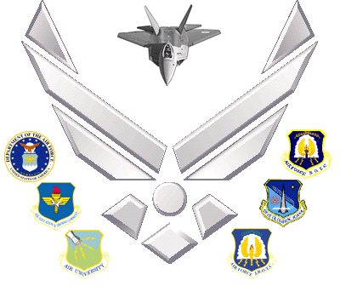

CHAPTER TWELVE
PROMOTION OF CADETS

1. The challenge and opportunity for promotion in rank reflects visible evidence of the progression of a cadet in the AFJROTC program. All cadets are assigned their minimum permanent grade commensurate with the number of AFJROTC years satisfactorily completed:

- First-year cadets- Airman
- Second-year cadets- Airman First Class
- Third-year cadets- Senior Airman
- Fourth-year cadets- Staff Sergeant

Permanent grades may be awarded after the first nine weeks of each school year when a cadet shows a minimum of a C grade in their Aerospace Science Class and passing grades in all other classes. Additional permanent rank may be awarded at the end of each semester by cadets completing the documentation showing GPA from their grade reports by the deadline given by the class instructors, with one additional rank added if the cadet reaches:

- First-year cadets- GPA of 2.5 or above
- Second/Third/Fourth-year cadets-GPA of 2.5 or above

The giving and retention of permanent grades based on the above schedule is contingent upon satisfactory performance and behavior as determined by the AFJROTC unit senior cadet staff, serving as a promotion review board, with the instructors and the SASI as the final reviewing authority. Permanent officer status will be awarded to cadets holding officer positions for two or more grading periods. Exceptions are authorized at the discretion of the senior cadet staff and instructors for exceptional circumstances.

2. (In accordance with the AFJROTC Guide) Cadets may be assigned a temporary grade based on the obtainment of a specific position. Use of a temporary-permanent grade pattern is intended to serve as an administrative vehicle for rotation of responsibility and to avoid imbalances in grade structure. Cadets serving in a temporary grade may revert to their permanent grade upon completion of these duties. At the discretion of the senior cadet staff, acting as a promotion review board, the AFJROTC Instructors, and the SASI serving as the final reviewing authority, cadets in their final term of AFJROTC may retain the highest rank to which they have been promoted, regardless of course level.

3. The Cadet Group Commander will be chosen each year by the JROTC instructors with the SASI as the final reviewing authority. The Cadet Group Commander and the instructors will nominate and chose cadets to serve in other leadership positions. Senior cadet officers will recommend cadets to fill NCO and Flight Commander positions. Flight Commanders will recommend cadets for all flight positions.
The SASI will be the final reviewing authority for all positions and corresponding promotions. Corresponding ranks to positions are listed in Chapter Fifteen of this Cadet Guide.
4. AS 3 (third year) and AS 4 (fourth year) cadets will fill cadet officer positions. AS 2, 3, or 4 cadets will fill NCO positions. Consideration is given for previous military experience, such as Civil Air Patrol and/or prior JROTC training. AS 1 (first year) cadets are normally not considered for cadet Senior NCO or cadet officer positions. Under exceptional circumstances, with the review of the senior cadet staff, the instructors, and with the SASI as the final reviewing authority an AS 1 may be considered for senior NCO positions, on a case by case basis.

5. All cadet positions are subject to rotation each semester, at the recommendation of the senior cadet staff and instructors, with the SASI as the final reviewing authority.

6. The senior cadet staff, made up of the Cadet Group Commander, Cadet Deputy Commander, Cadet Senior Enlisted Advisor, First Squadron Commander, Second Squadron Commander, Mission Support Squadron Commander, and Logistic Squadron Commander, will act as the cadet promotion review board.

7. Demotion of cadet rank may be recommended to the SASI by the senior cadet staff or instructors due to continued failure to perform cadet duties, indifference, inaptitude, failure to respond to counseling, or other serious deficiencies in the cadet’s performance.

CHAPTER THIRTEEN
SPECIAL SAFETY POLICIES

- Cadets will never take a weapon (de – milled rifle or sword) out of the storage without the direct approval of the SASI/ASI. The SASI or ASI will be present when they are being used. No cadet will ever take a weapon off school grounds with the permission of SASI/ASI. Cadets will never take them home to practice and weapons will be secured in the storage room at all times except for practice or a performance under lock and chain. Violations may result in removal from the school system for one year.
- The AFJROTC program will not tolerate any hazing of any type on cadets by any other cadets. Physical abuse, verbal abuse or sexual references are considered forms of hazing.
- The AFJROTC Anti – Drug Program has been adopted by the school and relies on your support. This program pays cash rewards but relies on cadets to pass timely information to the SASI or ASIs. Your participation has helped make this program a success.
- On all AFJROTC activities (dances,strips,service projects) whether on school grounds or off campus, ALL SCHOOL RULES apply and will be enforced. Remember all zero- tolerance infractions.

CHAPTER FOURTEEN
ORGANIZATION OF THE TN-944 AFJROTC GROUP

1. The following chart reflects the Cadet organization. Organization charts break the functions of the Group down to specialized tasks. The responsibilitits asociated with each task are foung in the corresponding job description in Chapter 16 in this Guide. Each cadet should become familiar with all of the job descriptions to gain a more complete understandting of those jobs as they relate to the total group.

2. The organization charts reflect a CHAIN OF COMMAND by a solid line connecting the functions or positions. Information, guidance, and decisions flow down the chain of command in the form of oral and written instructions. Information and reccommendations that are used by cadet leaders in decision making also flow up the chain of command. Information flow and coordination between lateral functions are also necessary for efficient staff functioning. Unless there is a free communications flow throughout the organization, the group will quickly become ineffective.

3. Cadets are to go through the chain of command if they have problems or questions. DO NOT GO DIRECTLY TO ANYONE ELSE. START WITH YOUR IMMEDIATE SUPERVISOR.

4. The appropriate chart in this chapter shows the relationship between Group Staff officers and staff specialists within each flight. The solid line between the flight commander and each staff specialist represents direct supervision.

5.Authorized leadership positions are shown in the Unit Detail Listing found in Chapter 15 in this guide. Cadets must learn the duties and responsibilities of their assigned positions and should learn as much as they can about the other positions in the group. Promotions will be based on job performance and potential for more responsible jobs.

CHAPTER FIFTEEN
UNIT DETAIL LISTING

TN-944 AIR FORCE JUNIOR ROTC GROUP

- Note: Whenever two grades are shown, the grade to the left is the beginning authorized grade. The grade to the right is the grade to which the cadet may be promoted at a later date. If a cadet is enrolled in two aerospace science courses at the same time, the higher year will apply.
FUNCTION | POSITION TITLE | YEAR | GRADE | NO.AUTH.
Command | Group  Commander | AS3/4 | Cadet Lt Col/Col | 1
Command | Deputy Commander | AS3/4 | Cadet Maj/Lt Col | 1
Command | Senior Enlisted Advisor | AS3/4 | Cadet SMSgt/CMSSgt | 1
Command | Squadron 1 Commander | AS2/4 | Cadet Lt-Major | 1
Command | Squadron 2 Commander | AS2/4 | Cadet Lt- Major | 1
Command | Flight Commander | AS 2/4 | Cadet Lt- Capt | 12
 | Flight Sgt | AS 1/4 | Cadet Ssgt/MSgt | 12
Command | Mission Support Squadron  Commander | AS3/4 | Cadet Lt- Major | 1
 | Drill Team Commander | AS3/4 | Cadet Lt-Capt | 1
 | Color Guard Commander | AS3/4 | Cadet Lt-Capt | 1
 | Public Affairs Officer | AS2/4 | Cadet 2Lt- 1Lt | 1
 | Public Affairs NCO | AS2/4 | Cadet Tsgt/MSgt | 1
 | Spt Flt Sgt/Public Affairs | AS2/3 | Cadet TSgt/MSgt | 1
 | Athletics Officer | AS2/3/4 | Cadet 2Lt- 1Lt | 1
 | Video Officer | AS2/3/4 | Cadet 2Lt- 1Lt | 1
 | Special Projects Officer | AS2/3/4 | Cadet 2Lt- 1Lt | 1
 | Kitty Hawk Commander | AS2/3/4 | Cadet 2Lt- 1Lt | 1
 | Personnel Officer | AS 2/3/4 | Cadet 2Lt- 1Lt | 1
 | Recruiting Officer | AS2/3/4 | Cadet 2Lt- 1Lt | 1
 | Recruiting NCO | AS2/3/4 | Cadet SSgt – TSgt | 1
 | Record NCO | AS2/3/4 | Cadet SSgt-TSgt | 1
Commander | Flight Commander | AS3/4 | Cadet 2Lt-Capt | 1
 | Log Flt Sgt/Supply | AS3/4 | Cadet MSgt/SMSgt | 1
 | Log Flt Sgt/Supply | AS2 | Cadet TSgt/MSgt | 2
 | Inventory NCO | AS2/3/4 | Cadet TSgt/MSgt | 1
 | MWR Officer | AS 2/3/4 | Cadet 2Lt- 1Lt | 1
 | Computer Officer | AS2/3/4 | Cadet 2Lt- 1Lt | 1

- Note: AS-1 Cadets can hold no rank above Senior Airman (E-4). If they serve in an NCO position on group staff, this is the rank they will hold.

CHAPTER SIXTEEN
JOB DESCRIPTIONS

As with the active Air Force, responsibilities and duties increase with rank. Each cadet is expected to prepare for assuming additional responsibility and higher positions. The following job descriptions outline the major duties of each leadership position contained in the UDL.

- Cadet Senior Staff: The Cadet Senior Staff consists of the following eight positions: Cadet Group Commander, Cadet Deputy Group Commander, Cadet Senior Enlisted Advisor, First Squadron Commander, Second Squadron Commander, Cadet Mission Support Squadron Commander, Cadet Logistics Squadron Commander and Cadet Drill Team Commander. The organizational chart at Figure 14-1 shows the functional relationship of each position along with their areas of responsibility.
  - Note #1: The requirements to become a member of Senior Staff are: (a) be a third or fourth year cadet (b)maintain a 2.5 GPA each grading period and a B in JROTC (c) is eligible for the temporary rank specified in the UDL (Chapter 15). Should a Senior Staff member fall below a 2.5 GPA for any given grading period, they will be placed on probation until midterm grades come out ( the next 4 ½ week point). If they fail to raise their grades to a 2.0 they will be replaced on staff and demoted back to their permanent rank.
  - Note #2: The Cadet Group Commander’s Special Staff consists of the Cadet Deputy Group Caommander, Cadet Senior Enlisted Advisor, and the Drill Team Commander. The commander may assign additional duties as necessary for the efficient operation of the Group to any of these Special Staff members.
- Cadet Group Comander (Must have completed the Cadet Leadership Course/CLC) is a C/Lt. Colonel or C/Colonel and there will be only one per semester. The Group Commander may be changed at the semester break or may remain in command for the entire year at the discretion of the SASI. The following are a list of duties:
  - Responsible for chairing Group Staff (held week) meetings. The Group Staff meetings will consist of the Cadet Senior Staff, or the Cadet Group Commander’s Special Staff, as called each week by the Cadet Group Commander.
  - Leading and setting the best possible example to the cadet group. Integrity must be beyond reproach, uniform must be near-perfect every time its worn, and he or she must walk the walk of a model citizen and scholar at Haywood High School, and he or she must be more actively involved in community service and cadet projects than anyone else in the Group.
  - Ensures that strategic planning is accomplished and carried out which supports the goals of Air Force Junior ROTC.
  - Makes sure that subordinate staff members are trained in their jobs and are performing their jobs to the best of their ability.
  - Leads the group in special functions. e.g. President of the Mess in dining outs, commander of troops at parades and reviews, etc.
  - Knows everything that is happening in the cadet group, e.g. time and dates of functions, personnel problems between cadets, and difficulties or obstacles causing problems on cadet programs. The Cadet Group Commander is the direct link between the Cadet Corps and the ASI and SASI. The Cadet Commander will keep the instructors fully informed of all the group’s activites, functions, and problems by meeting with them at least once daily and especially the day prior to the Group Staff/Senior Staff meetings.
  - Ultimately responsible for the discipline within the group, to include customs and courtesies, wearing of the uniform, classroom demeanor, and drill and ceremonies.
  - Responsible for ensuring those new cadets and trained properly in the core values and the Honor Code.
  - Organizes his or her group staff to ensure that duties are fairly distributed and delegated to ensure the efficient day-to-day running of the Cadet Group.
- Cadet Deputy Group Commander (Must have completed the Cadet Leadership Course/CLC) is a C/Major or C/Lt. Colonel. His or her function is to assume the duties of the Group Commander in his or her absence (either temporary or extended absence). This is usually a learning position and the person occupying this position will be in line to move up in future semesters or years. As such, the Deputy Group Commander should be attempting to learn as much as possible while watching the commander do the job. In addition to being ready to assume the duties as commander, the Deputy Group Commander has the following duties:
  - Acts as the Group Inspector General (IG). In this capacity, it is his job to investigate all complaints or problems surfaced in the Group by group members. Upon completion of his/her investigation he/she will advise the commander and the SASI/ASI of his/her finding and recommendations. He or she may also be called upon to investigate a violation of the Honor Code or other disciplinary infractions and make recommendations for convening a Group Disciplinary Board.
  - Set the best possible example of integrity, wear of the uniform and treating people fairly and with dignity.
  - Keeps track of the following teams:
    - Kitty Hawk, Model Rocketry Club, Awareness Presentation Team, American Modeling Association, and any other team that may be created.
4. Senior Enlisted Advisor is a C/MSgt-Chief MSgt. He/she serves on the Commander’s Special Staff along with the Drill Team Commander and the Deputy Group Commander. This is the top enlisted position in the Cadet Group. His/her job is to represent the enlisted cadet force’s concerns to the Senior Group Staff and to be primarly concerned about the new freshman or first year cadets. It is his or her job to:
  - Assist the commander in maintaining the highest morale within the group by identifying problems and solutions people are having within the group. He/she should assist the Deputy Commander in his/her IG role.
  - Work with the Morale, Welfare, and Recreation (MWR) NCO in planning functions that support the mental health and well being of the Group. Suggest programs that will be responsive to Cadet feedback concerning this area.
  - Assist the commander with disciplining the enlisted ranks.
  - May work on any number of projects for the Commander. A “jack of all trades” and capable of filling in where the enlisted perspective is needed. This position will normally be filled by the top 2nd year cadet and is a growing position for a future command of the Cadet Group.
5. Drill Team Commander

  - The Drill Team Commander prepares practice schedules, secures a place to practice, and makes sure the faculty advisors are available (i.e. SASI). A printed schedule should be given to the SASI and published on the bulletin board so the team knows what to expect during practice.
  - Must participate on one of the competiting drill teams in competition.
  - Keeps an attendance record of all practices. Provides percentage attendance to the SASI so awards, merits, and patches can be given to the appropriate team members.
  - Responsible for signing out equipment and uniform items to the team and ensuring all equipment is returned at the end of the season or when a member drops off of the team.
  - After consulting with the SASI and the Drill Team members, selects the competitions the team wishes to attend.
  - Keeps the Senior Staff informed of Team activities and supports the Group’s recruting and community service efforts.
  - Ensuring all items required for competitions are inventoried and ready to go. Ensures all equipment is loaded onto vehicles going to drill meets. Inventories all items for return home from meets.
  - After consulting with the SASI and making imputes on who gets the Berets, Patch, Cord, and Ribbon.
  - Selects the competition commanders for the events at the meets after consulting with the Team Deputy Commander, SASI.
  - The Drill Team Commander will supervise the training of the Rookie Drill Team.

6. Color Guard Commander

a. Perform the duties of the Drill Team Commander in his/her absence and any other duties assigned by the Team Commander.
b. Must participate on one of the competing color guard teams.
c. Consult with the Team Commander on practice times and locations.
d. Keep the Drill Team Commander informed so that he can keep the Senior Staff informed.
e. Make sure that the people who attend Color Guard practices are being written down, and the list are being put in the Senior Staff cabinet and put in the Drill Team Folder.

Squadron Commanders serve in the grade of C/Capt through Lt. Col. There are four squadrons in the Cadet Group: First and Second Squadron, Mission Support, and Logistic Squadron.

7. First and Second Squadron

a. First and Second Squadron Commanders command fourteen flights (Alpha through Mike) representing the seven periods of school. Everyone in the cadet group is attached to one of the fourteen sections administratively; therefore, the squadron commander has the entire manpower pool under his/her command. The commander’s responsibilities are:
1. Being a member of the Senior Staff and attending all Group Staff and Senior Group Staff meetings.
2. Attend most of the Group functions, demonstrating commitment to the goals and mission of the Cadet Group.
3. Responsible for motivationg the members of the sections to get involved in the programs supporting the Group goals.
4. Responsible for the discipline within the cadet section.
b. Flight Commanders - As a leader, he/she must maintain the same standards as the First and Second Squadron commanders. He/she is respomsible for the running of the flight on a day-to-day basis. There will be 14 possible flight leaders in First and Second Squadron. The following are the duties of the Flight Commanders:
1. Responsible for the daily discipline of the flight during JROTC class.
2. Begins each class period with calling the flight to attention and taking the daily report, which will be given to the SASI at the start of the period.
3. Responsible for the drill training during the class period.
4. Responsible for training element leaders, assistant element leaders, flight and guidons.
c. Element Leaders - This person is responsible for those people in his/her element. He/she will take attendance and report it to the Flight Sergeant at the beginning of each class. He/she will assist in the training and discipline of the people within his/her element.
d. Assistant Flight Element Leaders. These people have the same duties as the Element Leaders and will assume the element lead in the absence of the element leader.

3. Mission Support Flight

a. The Mission Support Flight Commander serves in the grade of C/Captain through Lieutenant Colonel. The Mission Support Squadron is responsible for all those functions that a support group on an airbase may have as their responsibility: morale,welfare, and recreation; services; and public affairs. The commander’s responsibilities include:
1. Being a member of the Senior Staff and attending all Group Staff and Senior Staff meetings.
2. As a commander, he/she must see to it that all members of all flights are briefed weekly on the information disseminated during the Senior/Group Staff Meetings.
3. Attend most of the group functions, demonstrating commitment to the goals and mission of the Cadet Group.
4. Responsible for the discipline within the flight.
5. Responsible for motivating the members of the flight to get involved in the programs supporting the Group Goals.
6. As any officer, set the best possible example of intregrity, wear the of the uniform, and treating people fairly and with dignity.
7. Train each flight commander personally in his/her tasks.
b. Athletics Officer serves in the grade of C/2nd Lt. to C/1Lt. The officer is responsible for:
1. In charge of running a strong athletics program or cadets to earn the Physical Fitness Ribbon.
2. Maintaining an accurate and complete copy of all cadets earning the PF ribbon.
3. Make sure cadets are aware of the LETTER JACKET PROGRAM.
4. Making sure cadets are qualified to receive the ROTC letter and informing SASI.
c. Video Officer serves in the grade of C/2nd Lt. to C/1Lt. The officer is responsible for:
1. Making sure all cadet functions are video taped of have digital camera pictures.
2. Maintaining video equipment and making sure enough clean tapes are available.
3. Making sure cadets who use video equipment are checked out in proper use.
4. Making sure tapes are labled for future reference.
5. Making end of year CD/DVD for cadets/scrapbook/competitions.
e. Public Affairs Officer serves in the grade of C/2 Lt. to C/1Lt. The following are the duties apply to this officer and their staff:
1. Responsible for internal (to the Group) and external communication.
2. Prepares the Cadet Newsletter monthly to be published on webpage no later than every month. Articles for the newsletter may be written by anyone in the AFJROTC but will be edited by PA officer. The S/ASI will review the letter prior to publishing on the internet.
3. Responsible for preparing the bulletin boards within the AFJROTC room. The boards will be updated quartely.
4. Responsible for newspaper articles which display the service projects and activities of the TN-944 Cadet Group in a positive light. Articles should be written and submitted to the S/ASI for approval as often as activities merit.
5. Work closely with the Recruiting NCO in their efforts to recruit from feeder schools and on campus student body.
6. Work closely with Haywod High School’s Multi-Media department to highlight upcoming events and any significant achievements by individual cadets or teams.
f. Special Projects will serve in the grade of C/2nd Lt. to C/1Lt. Special Projects is responsible for the following:
1. Being the centralpoint of contact for all recreational, fitness, social programs that enhance the group’s morale. Examples are Military Ball, Awards Ceremonies and the Banquet.
2. The Special Projects Officer will have meetings to include all cadets who wish to participate in planning, executing, and cleaning up for these events.
3. Make sure these events are well publicized.
g. Personnel Officer serves in the grade of C/2nd Lt. to C/1Lt. Due to the importance of this function, this officer holds a higher position than most other officers. These duties include:
1. Entering all data into the Cadet Personnel Database and insuring its accuracy.
2. Maintaining complete and accurate cadet records on every active, reserve, and inactive cadet in the Cadet Group.
3. Prepare personnel promotion folders for Promotion Boards and Disciplinary Boards. Update cadet records with board actons and findings following the meeting within thre academic days.
h. Kitty Hawk Commander will hold the rank of C/2Lt. to C/Capt. The Kitty Hawk CC will be responsible for evaluating members for membership. The minimum will be a 3.00 GPA, no course below a C, exemplary discipline record and of good moral conduct. The Honor Society’s main job is to tutor students who are having problems in academic subjects. Usual tutor days are Tuesday and Thursday mornings, prior to school in the AFJROTC classroom. The CC should check with the S/ASI and ensure that all students who need help are receiving it.
i. RECRUITING OFFICER/NCO. Auth. Grade: Cadet 2Lt - 1Lt. Supervises the Recruiting NCOIC. Responsible for:
1. Holding a recruiting week in the commons in November each year to recruit for 2nd Semester.
2. Building recruiting posters for school hallways.
3. Tracking and coordinating the award of the AFJROTC recruiting ribbon to qualified cadets.
4. Other duties as assigned by the Support Squadron Cdr, Grp Cdr, or the SASI/ASI.

4. Logistic Flight

a. The Logistics Flight Commander will serve in the grade of C/2Lt. to C/1Lt. The Logistics Squadron is responsible for all real property: its upkeep, inventory, recording, repair, and support. The following are the responsibilities of the Squadron Commander:
1. Ensuring staff officers know of any new job requirements.
2. Enforcing appearance, discipline, and efficiency of cadets under them.
3. Holding meetings with staff as necessary.
b. Logistics NCO will serve in the grade of Cadet TSgt/MSgt. The following are the responsibility of the NCO:
1. Train each NCO personally in their task.
2. Work closely with the ASI in issuing and taking up uniforms at the beginning and end of each semester.
3. Assist the ASI taking inventory for uniforms and textbooks.
4. Assist the S/ASI in issuing text books and workbooks.
5. Notify the S/ASI in issuing text books and workbooks.
6. Notify the S/ASI whenever we begin to get in a low supply for ribbons or badges etc.
7. Work with the Personnel Officer and Administrative Officer when preparing for awards ceremonies so that the proper number of ribbons and badges are available to make awards.
c. Inventory NCO will serve in the grade of Cadet TSgt/MSgt. The following are the responsibility of the NCO:
1. Train each NCO personally in their task.
2. Work closely with the ASI in issuing and taking up uniforms at the beginning and end of each semester.
3. Assist the ASI taking inventory for uniforms and textbooks.
4. Assist the S/ASI in issuing text books and workbooks.
5. Notify the S/ASI in issuing text books and workbooks.
6. Notify the S/ASI whenever we begin to get in a low supply for ribbons or badges etc.
7. Work with the Personnel Officer and Administrative Officer when preparing for awards ceremonies so that the proper number of ribbons and badges are available to make awards.

d. MWR OFFICER (SS/MWR). Auth. Grade: C/2Lt - C/1Lt. Supervises the Services NCOIC. Responsible for:
- Working closely with SASI/ASI concerning social activity needs. Will maintain an electronic folder on Google Drive for continuity and logging cadet participation.
- Organize and execute at least one social function for the corps each semester.
- A permanent board member for all Social Committees.
- Assists all Social Committees on matters of etiquette and protocol.
- Ensures SASI/ASI approves all official cadet gatherings.
- Other duties as assigned by the Support Squadron Cdr, Grp Cdr, or the SASI/ASI.
e. Computer Officer serves in the grade of C/2nd Lt. to C/1Ltt. The officer is responsible for:
1. Maintaining the cleanliness and appearance of computer labs.
2. Keeping computers in working order and identifying problems to SASI.
3. Making sure cadets use the computers for proper purposes and only cadets who have school parent permission letter use the internet.
4. Set up new programs on computers.

CHAPTER SEVENTEEN
INSIGNIA, BADGES, AWARDS, AND PATCHES

1. A number of distinctive awards are authorized for AFJROTC cadets to recognize outstanding academic and leadership performance or for a specific display of valor. Medals, ribbons, and certificates are awarded in the following categories:
2. Insignia, Badges, and Patches.
a. Ground School Badge. Awarded for completion of the honors ground school curriculm option or completion of an aviation ground school program prescribed by the FAA. Seniors may wear the badge after the first grading period if they are receiving a passing grade. Only cadets with a C or better in the Principals of Flight course and approved by the SASI may be enrolled in the honors course. OPR: HQ AFOATS/SDLJ.
b. Flight Solo Badge. Awarded to any cadet possessing a solo certificate signed by an FAA certified flight instructor for either powered or unpowered aircraft. OPR: HQ AFOATS/SDLJ.
c. Flight Certificate Badge. Awarded to any cadet who possesses an FAA flight examiner pilot’s certificate for either powered or unpowered aircraft. OPR: HQ AFOATS/SDLJ.
d. Awareness Presentation Team Badge. Awarded for participation in an Awareness Presentation Team. Only three APT members will be selected for the Group. These cadets will be selected on their public speaking ability by the SASI after they prepare and present a 5-minute briefing on why to become a member of Junior ROTC. OPR: AFROTC/DOJO.
1) APT is an academic endeavor designed to provide role models for elementary and middle school students. It also provides a practical application of the skills learned in the leadership education portion of the AFJROTC curriculum.
2) An APT team is normally composed of three cadets selected by the SASI based on their demeanor, verbal abilities, and professional appearance. The teams are responsible for selecting topics, conducting research, writing, and presenting the material used. The SASI in concurrence with the pricipal is the topic/content approval authority.
3) Team members should not be considered or advertised as experts. They should be prepared to deliver brief presentations on a topic of current interest that can include, but is not lmited to high school dropouts or drug use/abuse. Question and answer sessions are not part of APT presentations. All APT presentations must be cleared and approved by the high school principal.
4) Submit AFROTC Form 225, Awareness Presentation Team Feedback, to AFROTC/DOJO upon completion of an APT presentation.
e. American Modeling Association (AMA) Wings. Awarded to cadets who are members of the model airplane club. Cadet must join the AMA and present proof of membership to the ASI prior to receiving their wings. Contact the AMA to obtain badge for qualifying cadets.
f. Distinguished AFJROTC Cadet Award. This annual award consists of a certificate and a Distinguished AFJROTC Cadet Badge. The award recognizes one outstanding second-year cadet (third-year cadet in a four-year program). Selection is made at the end of each school year. This allows the recipient to wear the award throughout their final year in the AFJROTC program. The reipient must be of high moral character, demonstrate positive personal attributes, display outstanding military potential, and maintain consistent academic and military excellence. The recipient must also hold the following awards prior to selection:
Leadership Ribbon
Achievement Ribbon
Superior Performance Ribbon
Academic Ribbon
Co-curricular Activities Leadership Silver Star
Service Ribbon
The SASI, with the concurrence of the principal, selects the recipient. Cerifcates and badges are distributed each March by AFROTC/DOJO.
g. Aerospace Education Foundation (AEF) Academic Cadet Award. Awarded to rising Junior and Senior cadets for academic excellence as signified by attaining an overall 3.3 grade point average with no grade below “C” on their transcript. The individual must be recommended by the SASI. OPR: AFROTC/DOJO.
h. Model Rocketry Badge. Awarded to cadets who have fulfilled model rocketry program requirements. OPR: HQ AFOATS/SDLJ.
i. First Sergeant Insignia. Cadets MSgt or above assigned to first sergeant duties are authorized to wear the miniature diamond. The first sergeant diamond is centered directly above the metal chevron rank.
j. Nametags. Nametags are authorized but are not required for wear with all uniforms (except the 1620 service dress coat). Use the standard Air Force blue nametag. If nametags are used, they must be worn by all cadets. Two-line nametags are authorized for cadets that hold specific Corps positions. The cadet’s last name will appear on the first line and the Corps position, such as Commander, Deputy Commander, Color Guard, Drill Team, etc., will appear on the second line. The wear of multiple nametags is prohibited.
k. AFJROTC Shoulder Patch. Wear of the AFJROTC official shoulder patch is mandatory on all outer garments except the raincoat, overcoat, and all weather coats. Cadets enrolled in Civil Air Patrol (CAP) and AFJROTC who use the same uniform for both activities may wear the CAP wing patch on the right shoulder and the AFJROTC patch on the left shoulder with the AFJROTC shoulder patch taking precedence.
l. Unit Shoulder Patch. AFROTC/DOJO is the approval authority for all unit shoulder patches. If a school/unit patch is used, all cadets will wear it. The overall dimensions of the school patch will not exceed 3-inches by 31/4-inches for rectangle and 3-inches in diameter for round patches to include any boarder material. The AFJROTC emblem is for the exclusive use of AFJROTC and should not be altered of included in the design of school shoulder patches. Wear the AFJROTC patch on the left and the school patch on the right sleeve ½ to 1 inch below the outer shoulder seam.
m. Drill Team and Color Guard awards – Ribbon criteria is prescribed in the cadet guide pg.60 sect.2, and 33; if the cadet will attend at least 75% of practices for a semester period you receive a Drill Team and Color Guard ribbon. Completion of each semester after that initial semester the cadet received an oak leaf cluster for 75% attendance. The ribbon and oak leaf cluster will be kept if you leave the team. The Rope will be earned after 4 ½ weeks of 75% attendance. The cadet will keep the rope until the cadet does not meet the attendance criteria. The Shoulder Tab will be earned after 1 ½ semester of 75% attendance. The cadet will keep the patch until the cadet does not meet the attendance criteria. If attendance requirements are not met, the rope and patch will be returned.

n. AFJROTC SCHOOL LETTERS – (Currently not adopted but it is optional at the discretion of the Senior Staff)
a. Only one letter jacket can be issued per person. Basic requirements for earning and wearing the letter jacket for any AFJROTC student who attends Nitro High School are fourfold: (1) Participate in four drill meets. (2) Complete four semeters on the Drill Team or Color Guard. (3) Do 10 Color Guard/2 Drill meets/ 4 service projects. (4) Do 6 service projects and be a cadet of the month; * cadet of the month or attending SLS will count as 2 service projects. The jacket will be aproved by the SASI.
o. Cadet of the Month – each flight commander will select one cadet of the month for each 9 week grading period. The cadet will receive 5 points on their 9 week grade. The cadet will be approved by the SASI/ASI and will have shown exemplary performance and bearing during the period.
3. National Awards and AFJROTC - National awards are presented to cadets selected by the SASI and approved by the principal. These awards are authorized by AFJROTCI 36-2001. Cadets may refer to eligibility criteria in the subject regulation upon request.
a. Awards and Decorations – The Cadet awards and Decorations program fosters morale, espirit de corps, and recognizes achievements of AFJROTC cadets. Awards sponsored by national organizations are donated through local chapters where available. If local chapters are unable to furnish award elements, units may purchase them commercially at no expense to the Air Force with the permission of the sponsoring organization.
(1) All devices will be worn in accordance with the attachments of this instruction.
(2) Minimum criteria are prescribed to preserve the integrity of decorations. Units are authorized to impose additional criteria to meet local standards and needs without diminishing minimum standards.
b. Presentation and Publicity – Present awards at appropriate ceremonies. Invite school officials and local civil authorities when practical. Representatives from organizations sponsoring awards should be offered the opportunity to make the award presentation. Display awards when possible for the benefit of the cadet corps. The SASI will ensure that Air Force endorsement of any agency’s product or service is neither stated nor immplied.
(1) An award’s sponsoring organization may require a written report before final cadet selection or after presentation is made. Reports may include information such as : name of the award; name(s) of recipient; place and date of presentation; occasion (graduation, award banquet, etc.,); and name, title, and organization of award presenter.
c. Order of Precedence:
Valor Award (Gold)
Valor Award (Silver)
Cadet Humanitarian Award
Air Force Association Award
Daedalian Award
American Legion Scholastic Award
American Legion General Military Excellence Award
Daughters of the American Revolution Award
American Veterans Award
Reserve Officers Association Award
The Military Order of World Wars Award
The Retired Officers Association Award
Veterans of Foreign Wars Award
National Sojourners Award
Sons of the American Revolution Award
Scottish Rite, Southern Jurisdiction Award
Military Order of the Purple Heart Award
Air Force Sergeants Association Award
Non Commisioned Officers Association Award
Tuskegee Airmen Incorporated Air Force Junior ROTC Cadet Award
Outstanding Cadet Ribbon
Leadership Ribbon
Achievement Ribbon
Superior Performance Ribbon
Outstanding Unit Award
Excellent Unit Award
Academic Ribbon
Outstanding Flight Ribbon
Leadership School Ribbon
Drill Competition Ribbon
Orienteering Competition Ribbon
Cocurricular Activities Leadership Ribbon
Drill Team Ribbon
Color Guard Ribbon
Sabre Team Ribbon
Service Ribbon
Physical Fitness Ribbon
Recruiting Ribbon
Activities Ribbon
Attendance Ribbon
Good Conduct Ribbon
Dress and Appearance Ribbon
Longevity Ribbon
Bataan Death March Memorial Hike Ribbon
General Carl Spaatz Award (CAP)
Amelia Earhart Award (CAP)
General Billy Mitchell Award (CAP)
General J.F. Curry Achievement Award (CAP)

d. Devices – If a ribbon is initially awarded with a star, an additional award will be indicated by adding a star. Additional awards of ribbons initially awarded without devices will be indicated by the addition of clusters. Wear a maximum of four devices on each ribbon. Place silver devices to the wearer’s right of bronze devices. Replace the bronze device with a silver device after receipt of the fifth bronze device. Place clusters horizontally and tilt slightly downward to the wearer’s right to allow maximum number of clusters and other devices on the ribbon. Tilt all or none. If all devices do not fit on a single ribbon, wear a second ribbon. When future awards reduce devices to a single ribbon, remove the second ribbon.
e. Ribbons of Other Services – AFJROTC cadets are authorized to wear ribbons earned while enrolled in United States Army, United States Navy, United States Marine Corps, or United States Coast Guard JROTC. Group ribbons according to service with the order of precedence determined by the regulations of each service. AFJROTC cadets will wear AFJROTC ribbons ahead of other service JROTC ribbons or awards. Other services’ ribbons are grouped by service in the following order: Army, Navy, Marine Corps, and Coast Guard. Only four CAP ribbons (General Carl Spaatz Award, Amelia Earhart Award, General Billy Mitchell Award, and General J.F. Curry Achievement Award) may be worn on the AFJROTC uniform. Badges or insignia from Active Duty, Guard, Reserve, or any other non- AFJROTC group are not authorized on the AFJROTC uniform.
- Note: Valor Awards – Valor awards from all services are worn ahead of all other ribbons from any service. The AFJROTC Valor Awards will be worn first, with other services’ Valor Awards worn in the following order: Army, Navy, Marine Corps, and Coast Guard.
f. Medals are ribbons may be worn simultaneously for formal, semiformal, special occasions of a limited nature. The routine wear of medals and ribbons is prohibited.
g. Descriptions and Criteria
1) Gold and Silver Valor Award – Awards consist of a medal, ribbon, and citation. The Gold Valor Award recognizes the most outstanding voluntary acts of self-sacrifice and personal bravery by a cadet involving conspicuous risk of life above and beyond the call of duty. The Silver Valor Award is awarded to a cadet for a voluntary act of heroism which does not meet ther risk-of-life requirements of the Gold Valor Award.

Forward recommendations for valor awards to AFROTC/DOJO for review and approval within 6 months of the incident. Include a detailed description of the situation, newspaper clippings (if available), statements by victims and observers, and any other information deemed appropriate to validate eligiblilty. In addition, submit a proposed citation to accompany ther award. Upon arrivial, AFROTC/DOJO distributes the citation, medal, and ribbon for presentation.

2) Cadet Humanitarian Award—Award consists of a ribbon and certificate and recognizes humanitarian effort or performance by cadets involving actions above and beyond the call of duty.

Forward recommendations for humanitarian awards to AFROTC/DOJO for review and approval within 6 months of the incident. Include a detailed description of the situation, newspaper clippings (if available), statements by victims and observers, and any other information deemed appropriate to validate eligiblilty. In addition, submit a proposed citation to accompany ther award. Upon arrivial, AFROTC/DOJO distributes the citation, medal, and ribbon for presentation.

3) Air Force Association (AFA) Award—This AFA-sponsored award consists of a medal and a ribbon and is presented annually at each unit to the outstanding second-year (in a 3-year program) or third-year cadet (in a 4-year program). Report Required.

a. The award recipient must possess/meet the following personal chacteristics and eligibility critera:

1. Positive attitude (towards AFJROTC and school)
2. Outstanding personal appearance (uniform and grooming)
3. Display personal attributes such as initiative, judgement, and self-confidence.
4. Courteous demeanor (promptness, obedience, and respect for customs)
5. Growth potential (capacity for responsibility, high productivity, adaptability to change)
6. Possession of the highest personal and ethical standards and strong positive convictions.
7. Rank in the top 5% in their AS class.
8. Rank in the top 10% of their academic class.
9. Be recommended by the SASI for the Outstanding Cadet Ribbon.

b. The SASI, as chairman, with the ASI and other faculty members, selects the recipient by April 1st . Upon selection, the SASI requests the award from the Director of ROTC Affairs, Air Force Association.

4) Daedalian Award - The Order of the Daedalians is a fraternity of commissioned pilots from all militery services. It is named after the legendary figure, Daedalus, and was organized by WWI military pilots who sought to perpetuate the spirit of patriotism, love of country, and the high ideals of self-sacrifice which place service to the nation above personal safety and position. This award is offered to encourage the development of these traits in cadets and to interest them in a military career. The medal is fashioned after an ancient Grecian plaque discovered by a Daedalian in the village of Lavadia, Greece and depicts Daedalus and his son Icarus fabricating their legendary wings of wax and feathers. This award also includes a ribbon.

a) This annual award recognizes one outstanding third-year cadet at each unit and meets the following critera:

Demonstrate an understanding and appreciation of patriotism, love of country, and service to the nation.
Indicate the potential and desire to pursue a military career.
Rank in the top 10% of their AS class.
Rank in the top 20% of their school class.

b) The SASI selects the recipient and requests the award from the nearest Daedalian Flight. A minimum of 90 days notice is required to allow the local chapter to obtain the award from their national headquaters and to schedule a Daedalian Flight presenter for the award.

5) American Legion Scholastic Award – This award consists of a bronze medal accompanied by a ribbon with a distinctive miniature attachment depicting a scholastic scroll. Report required.

a) This award is presented annually to one second – or third year cadet (in a 3- year program) or a third – or fourth year cadet (in a 4- year program) based on the cadet’s overall scholastic achievements. Each cadet must:

Rank in the top 10% of the high school class
Rank in the top 25% of their AS class
Demonstrate leadership qualities
Actively partcipate in student activities

b) The SASI, as chairman, with the ASI and at least one faculty member, selects the recipient and must request the award not later than 15 April. The award devices and presenter can be requested from the nearest American Legion Post.

6) American Legion General Military Excellence Award - Thid award consists of a bronze medal accompanied by a ribbon with a distinctive miniature attachment depicting a torch.

a) This award is presented annually to one second or third year cadet (in a 3 year program) or a third or fourth year cadet (in a 4 year program) based on the cadet’s general military excellence. Each cadet must:

Rank in the top 25% of their AFJROTC class
Demonstrate outstanding qualities in military leadership, discipline, character, and citizenship.
b) The SASI, as chairman, with the ASI and at least one faculty member, selects the recipient and must request the award no later than 15 April. The award devices and presenter can be requested from the nearest American Legion Post. Report required.

7) Daughters of the American (DAR) Award - This award consists of a bronze medal and ribbon and is presented annually to one third-year (in a 3-year program) or a fourth-year cadet (in a 4-year program) that meets the following criteria:

Rank in the top 25% of their AS class
Rank in the top 25% of their high school class
Demonstrate qualities of dependability and good character
Demonstrate adherence to military discipline
Possess leadership ability and a fundamental and patriotic understanding of the importance of ROTC training

The SASI and principal select the recipient and must request the award and a presenter no later than 1 March. The award devices and presenter can be requested from the nearest DAR chapter. Report required.

8) American Veterans (AMVETS) Award - This award consists of a medal pendant amd ribbon and is presented annually to one qualified cadet that possess individual characteristics contributuing to leadership such as:

A positive attitude toward Air Force ROTC programs and service in the Air Force
Personal appearance (wearing the uniform, posture, and grooming, but not physical characteristics per se)
Personal attributes (initiative, dependability, judgement, and self-confidence)
Officer potential (capacity for responsibility, adaptability, and maintenance of high personal standards)
Obtained a grade of “A” (or the numerical equivalent) in their AS class
Be in good scholastic standing in all classes at the time of selection and at the time of presentation

The SASI selects the recipient of the award and submits a brief nomination letter and biographical sketch of the cadet to the state AMVETS department where the school is located. An AMVETS representative should make the presentation if a participating local post or department representative is avialable. Report required.

9) Military Order Of World Wars Award - This award consists of a bronze medal pendant, certificate, and ribbon and is presented annually to an outstanding cadet who has committed to continue the aerospace science program the following school year. Selection is based on outstanding accomplishments or service in the JROTC unit.

The SASI, with the concurrence of the principal, selects the recipient and completes the Military Order of World Wars (MOWW) citation by summarizing the cadet’s outstanding accomplishments or service to the unit. The citation and request for the medal, certificate, and ribbon are sent to the nearest local chapter of the MOWW. The SASI will make arrangements for a MOWW representative to make the presentation at an appropriate ceremony. If a local chapter is unavialable, contact the MOWW National Headquarters. If a member is not available, any active, reserve, or retired commissioned officer may present the award.

10) The Retired Officers Association (TROA) Award - This award consists of a medal pendant with ribbon and is presented annually to an outstanding second-year cadet (third-year cadet in a four-year program) who shows exceptional potential for military leadership. Each cadet must:

Be a member of the junior class
Be in good academic standing
Be of high moral character
Show a high order of loyalty to the unit, school, and country
Show exceptional potential for military leadership

The SASI selects the recipient subject to the final approval of the sponsoring TROA chapter. The SASI requests the award devices from the nearest TROA chapter. A TROA representative will make the award presentation. If a TROA chapter is not available in the area, the SASI sends the request to the Retired Officers Association Headquarters. Report required.

11) Veterans Of Foreign Wars (VFW) Award - This award consists of a medal pendant with ribbon and is presented annually to an outstanding second or third-year cadet in a three-year program (third or fourth-year cadet in a four-year program) who is actively engaged in the AFJROTC program and who possesses individual characteristics contributing to leadership. Each cadet must:

Have a positive attitude toward AFJROTC
Have outstanding military bearing and conduct
Possess strong positive personal attributes (such as courtesy, dependablity, punctuality, respect and cooperation)
Demonstrate leadership potential
Attaine a grade of “B” in AFJROTC with an overall average grade of “C” in all subjects for the previous semester
Be active in student activites
Not have been a previous recipent of this award

The SASI selects the recipient subject to the final approval of the sponsoring VFW chapter. The SASI requests the award from the nearest local post in February for presentation in April or May. A VFW representative will present the award at the appropriate ceremony. If no local post is available, or if the local post does not offer the award, obtain information by contacting the headquearters of the Veterans of Foreign Wars of the Uniter States. Report required.
12) National Sojourners Award. This award consists of a ribbon, medal pendant, and certificate, annually recognizing an outstadning first- or second-year cadet (second- or third-year cadet in a 4-year program) who contributed the most to encourage and demonstrate Americanism within the corps of cadets and on campus. Each cadet must:

Be in the top 25% of their academic class
Encourage and demonstrate ideals of Americanism
Demonstrate potential for outstanding leadership
Not have previously received the award

The SASI selects the recipient subject to the final approval of the sponsoring National Sojourners chapter. The SASI requests the award from the nearest local chapter in February for presentation in April or May. A representative from the National Sojourners will make the award presentation at an appropriate ceremony. If no local chapeter is available or if the local chapter doest not offer the award, contact the headquearters of the National Sojourners. Report required.

13) Sons Of The American Revolution (SAR) Award. This award consists of a bronze medal with ribbon and recognizes an outstanding second-year cadet in a 3-year program or third-year cadet in a 4-year program who is enrolled in the AFJROTC program. The recipient must exhibit a high degree of leadersip, military bearing , and all-around excellence in AS studies and not have previously received the award. Each cadet must:

Be currently enrolled in the AFJROTC program
Be in the top 10% of their AFJROTC class
Be in the top 50% of their overall class

The SASI and the Principal select the recipeie t of the award not later than 1 March. The SAR national headquearters furnishes the secretary of each applicable SAR state organization a list of the AFJROTC units in their state. A representative of SAR will present the award and correspond directly with each unit within their area. The SASI makes arrangement for presentation with the applicable state society or local chapter. Report required.

14) Scottish Rite, Southern Jurisdiction Award. This award consists of a medal, ribbon, and certificate and annually recognize an outstanding second-year cadet ina 3 year-program or third-year cadet in a 4-year program. Each cadet must:

Contribute the most to encourage Americanism by participation in extracurricular activites or community projects
Demonstrate academic excellence by being in the top 25% of class
Demonstrate the qualities of dependability, good character, self discipline, good citizenship and patroitism
Not have been previous recipients of this award

The SASI selects the recipient and requests the award from the nearest Scottish Rite Valley of the Southern Jurisdiction at any time during the calender year. With a 30-day notice, a representative of the Scottish Rite Valley of the Southern Jurisdiction will make the presentation at the appropriate ceremony. If no local unit is availabe, or if the local unit does not offer the award,obtain information by contacting the national headquearters of the Scottish Rite Valley of the Southern Jurisdiction. The star worn on the ribbon must be procured with privat or unit funds and will not be furnished by the sponsoring organization.

15) Military Order Of The Purple Heart Award. This award consits of a medal pendant with a ribbon and annually recognizes an outstanding second- or third-year cadet (third- or fourth-year cadet in a 4-year program) who is enrooled in the AFJROTC program and demonstrates leadership ability. Each cadet must.

Have a positive attitude toward AFJROTC and country
Hold a leadership positi0on in the cadet corps
Be active in school and community affairs
Attain a grade of “B” or better in all subjects for the previous semester
Not have been previous recipients of this award

The SASI selects the recipient and requests the award from the nearest Military Order of the Purple Heart unit in February for presentation in April or May. A representative of the Military Order of the Purple Heart will make the presentation at an appropriate ceremony, If no local unit is available, or if the local unit does not offer the award, obtain information by contacting the national headquarters of the Military Order of the Purple Heart.

16) Air Force Sergeants Association (AFSA) Award. This annual award consists of a medal pendant with a ribbon and recognizes an outstanding second- or third-year program (third- or fourth-year cadet in a 4-year program). The recipient must demonstrated outstanding qualities in military leadership, discipline, character, and citizenship. Each cadet must:

Be in the top 25% of the AFJROTC class
Demonstrate outstanding qualities in military leadership, discipline, character, and citizenship
Not have been previous recipients of this award

The SASI, as chairperson, with the ASI, recommends the recipient of the award at least 60 days prior the desired presentation date, but not later than 15 April. The SASI requests the award and an AFSA presenter from the nearest AFSA chapter. If information on the nearest chapter is not available, or if there is no active AFSA chapter in the area, the SASI will contact the AFSA international headquaters to obtain the name and address of the division president whose area of responsibility is nearest the requesting school. Report required.

17) Noncommissioned Officers Association (NCOA) JROTC Award - (This award may be deleted in AY 2000-2001) This award consists of a medal, ribbon, and certificte and annually recognizes the most outstanding cadet Noncommisioned Officer in the unit. Each cadet must consistently exhibit the best military bearing, personal appearance, deportment and leadership ability.

The SASI selets the recipient and requests the award from the nearest Noncommisioned Officers Association Chapter. A representative will make the presentation at an appropriate ceremony. If no local unit is available, or if the local unit does not offer the award, obtain information by contacting the Roadrunner Chapter #153, Noncommisioned Officers Association.

18) Tuskegee Airmen Incorporated (TAI) Air Force Junior ROTC Cadet Award - This TAI sponsored award consists of a ribbon and a certificate and is presented annually to two cadets. Cadets may be first – year, second – year, or third – year cadets (in a 3- or 4- year program) and must meet the following criteria:

Attain a grade of “B” or better in their AS class
Be in good academic standing
Actively participate in cadet corps activities
Participate in at least 50% of all unit service programs

The SASI and ASI select the recipients and must request the award not later than 1 March. The award devices and certificates can be requested from AFJROTC Unit SC-065, C.A. Johnson High School. A follow- up report is required after the award is presented. Provide SC-065 the names and grades of the recipients and date award was presented.

19) Outstanding Cadet Ribbon - Awarded annually to the outstanding first – year, second – year, third – year, and fourth – year cadet. The recipient from each class must be of high moral character, demonstrate positive personal attributes, display outstanding military potential, and attain academic and military excellence.

  - AS-1 cadet must also have qualified for and be awarded the Superior Performance Ribbon to be eligible.
  - AS-2 cadet must also have qualified for and be awarded the Superior Performance Ribbon to be eligible.
  - AS – 3 cadet must also have qualified for and be awarded the Superior Perforance and Achievement Ribbons to be eligible.
  - AS – 4 cadet must also have qualified for and be awarded the Superior Performance, Achievement, and Leadership Ribbons to be eligible.
  - A cadet can earn the Outstanding Cadet Ribbon without the prerequisite ribbons at Cadet Officer Leadership School (COLS) if he/she is designated the Outstanding Cadet of his or her flight.

21) Leadership Ribbon – Awarded for outstanding performance in a position of leadership as an AFJROTC cadet in corps training activities. Limit this ribbon to 5% of the eligible group to ensure recognition of cadets who have consistently displayed outstanding leadership ability above and beyond expected performance. To earn the Leadership ribbon, the recipient must have earned the Dress and Appearance ribbon, the Service ribbon, the Activities ribbon, the Good Conduct ribbon, the Academic ribbon, and the Superior Performance ribbon. However, a cadet officer and cadre memner at COLS may also earn the ribbon there without all the prerequisites.

22) Achievement Ribbon – Awarded for superior chievement on a particular project or event this is clearly above normal performance. The award may also be given to a cadet who performs clearly far above his or her contemporaties in a given semester. Limit this ribbon to the 5% of the eligible group. To earn the Achievement ribbon, the recipient must have earned the Dress and Appearance ribbon, the Service ribbon, the Activities ribbon, the Good Conduct ribbon, and the Superior Performance ribbon.

23) Superior Performance Ribbon - Awarded annually for outstanding achievement or meritorious service rendered specifically on behalf on AFJROTC. Present the ribbon for a single or sustained performance of a superior nature. Limit this ribbon to 10% of the cadet corps to ensure recognition of achievements and service, which are clearly outstanding and exceptional when, compared to achievements and accomplishments of other cadets. To earn the Superior Performance ribbon, the Activities ribbon, the Good Conduct ribbon, and the Attendance ribbon.

24) Outstanding Unit Award – Awarded to cadets enrolled during the period a unit’s “outstanding” rating is valid. Once earned by a cadet, he or she may wear it until graduation from high school or leaving JROTC.

25) Excellent Unit Award - Awarded to cadets enrolled during the period a unit’s “excellent” rating is valid. Once earned by a cadet, he or she may wear it until graduation from high school or leaving JROTC.

26) Academic Ribbon – Awarded for academic excellence as signified by attaining an overall grade point average of at least “B” (3.0 GPA or better) for one academic term, in addition to an “A” average in AFJROTC over the same grading period.

27) Outstanding Flight Ribbon – Awarded each academic term to members of the outstanding section under criteria determined by the SASI. This criterion involved section academic performance average, weekly inspection grades, and performance on fitness days, drill and evaluation performance, and leadership and followership within the section. This is a “TEAM” award where everyone contributes to the individual unit’s success.

28) Leadership School Ribbon – Awrded for completion of an approved leadership school program of at least 5 days duration. Add star for outstanding performance performance or leadership ability at a Leadership School. Limit the star to 10% of the class.

29) Drill Competition – Awarded to drill team members for “placing” (3rd or better in an event the cadet participates in) in an Air Force or Joint Service drill meet.

30) Orienteering Competion – Awarded to team members for “placing” (3rd or better in an event the cadet participates in) in an orienteering meet.

31) Co – Curricular Activities Leadership Ribbon – Awarded for leadership in AFJROTC co – cirricular activities (such as dining – in chairperson, military ball chairperson, etc.). The recipient must have demonstrated exceptional leadership in achieving objectives through the coordinated efforts of others.

32) Drill Team Ribbon – Awarded for distinguished participation in at least 75% of all scheduled drill team events. The basic ribbon is awarded the first semester block completed and an oak leaf cluster is awarded for each successive semester the cadet meets the 75% criteria.

33) Guard Bar Ribbon – Awarded for distinguished participation in at least 75% of all scheduled color guard events. The basic ribbon is awarded the first semester block completed and an oak leaf cluster is awarded for each successive semester the cadet meets the 75% criteria.

34) Saber Team Ribbon – Awarded for distinguished participation in at least 75% of all scheduled saber team events. The basic ribbon is awarded the first semester block completed and an oak leaf cluster is awarded for each successive semester the cadet meets the 75% criteria.

35) Service Ribbon – Awarded for distinctive performance in school, community, or AFJROTC service projects. Limit to members whose active participation in a service project contributed significantly to the goals of the organization. Clusters on the basic ribbon designate additional awards of the Service ribbon. To become eligible for the ribbon the cadet must participate in at least 50% of all service projects scheduled in a semester block, working at least one half the total time dedicated to the project.

36) Physical Fitness Ribbon – Awarded for sustained participation in a locally developed physical fitness program. The SASI awards this ribbon based on locally developed criteria. Criteria for the TN-944 Cadet Group are:

Warm up and stretching exercises

Mile run: 8 min. 00sec. (Males) 10 min. 00 sec. (Females)
Sit-ups: 42 in 2min. 42 in 2min.
Push-ups: 35 in 2 min. 19 in 2min.

37) Recruiting Ribbon - Awarded for outstanding effort in support of unit recruiting activities. Every cadet who recruits one cadet is eligible to receive the award.

38) Activities Ribbon – Awarded for participation in co – curricular competitive activities (drill meets, color guard competitions, parades, rocket meets, orienteering meets, academic meets, dining outs, field dys, etc.) The SASI awards this ribbon using locally developed criteria. In the 944th to qualify, a cadet must participate in the schedules activities.

39) Attendance Ribbon – Awarded to cadets with no more than 4 excused absences and no unexcused absences in a nine week period.

40) Good conduct Ribbon – Awarded to cadets with no detentions, suspensions of any kind, and no adverse reports from other staff or faculty in a semester.

41) Dress and Apperance Ribbon – Awarded for wearing uniform on all designated uniform days and conforming to all AFJROTC dress and appearance standards. Cadet must average at least 85% (43 points) or better on all uniform inspections. Limit this ribbon to 25% of the cadet corps.

42) Longevity Ribbon – Awarded for completion of each AS year.

43) Bataan Death March Memorial Hike Ribbon – To honor and remember the sacrifices of the victims and survivors of World War II’s Bataan Death March, AFJROTC units may conduct an optional 14 - mile Bataan Death March Memorial Hike. This event must be accomplished on a locally - determined 14 mile course (trails, road courses, tracks, etc.). Units may complete the full hike in a span of one to no more than three days. Cadet safety must be monitored at all times and advanced planning for any first aid/medical attention is paramount. Cadets who fully complete the 14 mile hike are authorized to wear the ribbon.

- Most awards will be presented at the semiannual Awards Ceremony. Appropriate ceremonies may be held at other times during which some awards may be presented. The Cadet Public Affairs NCO will arrange proper advance publicity. Families of recipients will be invited, time permitting, to attend these ceremonies.
- Engraved plaques and other examples of some these awards and decorations are on display in the Aerospace Science classroom. Other trophies and plaques are given annually at the Awards Banquet.
- Ribbons are worn above the left breast pocket of the uniform. The Model Rocketry Badge is worn verfically on the left pocket, centered and immediately below the pocket flap. Shoulder cords are worn on the left shoulder.
- AFJROTC cadets are authorized to wear ribbons earned while enrolled in Army, Navy, or Marine Corps JROTC, as well as the Civil Air Patrol. These ribbons will be worn below the AFJROTC ribbons in order of their precedence. The wear of ribbons is mandatory for all uniform inspections.
- Medals and ribbons may be ribbons may be worn on the semi – formal uniform for special occasions. Medals are worn instead of ribbons with the metallic portion of the medal immediately above the top of the pocket button. If both medals and ribbons are worn the medals will be centered ½” below the bottom row of ribbons. The order of precedence is the same as for ribbons.
- National Competitions:
  - Aerospace Education Foundation’s (AEF) JROTC Video Contest – The AEF in conjunction with the AFA, conducts a contest each year for AFJROTC units. New categories and subjects are selected each year by the AEF to supplement and reinforce the AFJROTC program. Certificates of merit are provided to 20 participants receiving honorable mention. A cash award of $500 and a plaque are presented to the four individual category winners. A special award of $1,000 and a distinctive plaque are presented to the overall winner of the contest.
    - AEF will forward the current year’s categories and subjects in November of each year to AFJROTC units. Submit contest entries to the AEF national headquaters. Each entry must be postmarked no later than March (date announced each year) to qualify for the contest. Do not forward entries to AFJROTC. Results of the judging are completed in late May.

    - Awards for honorable mention and individual catergories are forwarder to local AFA chapters for presentation. The AFJROTC overall winning entry is honored at the AFA national convention. The SASI, the school principal, and two cadets involved with the winning entry are AEF guests for the 3-day convention.

  - Freedoms Foundation at Valley Forge (FFVF) National Awards Military Contest. The Freedoms Foundation at Valley Forge, Pennsylvania, conducts an annualessay contest for cadets in ROTC prgrams. The competion is interservice and nationwide. Awards are combined for all services. The overall winner recieves a $100 United States Savings Bond and an encased George Washington Honor Medal. Runners-up receive the medal and a $50 United States Savings Bond. The top award winner is invited to Valley Forge, at no expense to recieve the award. The other awards are sent to the school for presentation at an appropriate cermony.
    - FFVF distributes the current year’s categories and subjects. A maxumum of five essays may be subitted by each unit for national competiton. Each unit is responsible for developing procedures for selecting the five best essays in the unit.
    - Submit entries in letter or essay format, typed on one side of standard bond paper. Entries must include the cadet’s name, rank, unit, home address, name, and address of the school. The entry must also specify the name and grade of the JROTC instructor. Entries must be no less than 100 words and no more than 500 words. Mail essays to the awards department of the Freedoms Foundation. Do not forawd entries to AFROTC. Each essay forwarded for national judging must arrive at the Freedoms Foundation not later than 1 May.
  - US Space and Missile Center Aviation Challenge Scholarship Program. The AEF and the US Space and Missile Center award four scholarships annually to AFJROTC cadets. A scholarship is awarded to one primary cadet (with one alternate cadet if the primary is unable to attend) from each region as selected by the region commander. The scholarship subsidizes transportation, room, board, and tuition costs to the Aviation Challenge program in Huntsville AL. Alternates may be subsidized in full or in part funds are available.
    - The Aviation Challenge program is avialable to rising fourth-year (4-year program) or rising third-year cadets (3-year program) with a financial need and academic excellence in school and AFJROTC. Candidates must also be pre-enrolled in their final year of AFJROTC.
    - The SASI selects one nominee and submits a brief desription of the canditate to the area manager, who selects the top candidate from the submission received. The region commander reviews and rank-orders letters received from area manages, selecting one award winner and one alternate. Nominations must arrive at AFROTC/DOJ NLT 15 May.

CHAPTER EIGHTEEN
CERTIFICATES OF COMPLETION AND TRAINING

- There are two types of certificates that may be awarded to AFJROTC cadets. They are the CERTIFICATE OF COMPLETION and the CERTIFICATE OF TRAINING. Descriptions of each follow:
  - Completion – Passing grads in each credit granting period of AFJROTC constitutes successful completion. Cadets may be awarded certificates even if they do not graduate from high school since the certificate is based only only on AFJROTC performance.
    - Cadets will be awarded AF Form 1256, Certificate of Training, for successful completion of 2 years of AFJROTC. AFJROTC Form 310, Cerficiate of Completion, will be awarded for successful completion of 3 years of AFJROTC. SASIs administering a 4-year program have the option of issuing AFJROTC Form 310 after 3 or 4 years. However, students leaving a 4 – year program after the 3rd year will be issued AFJROTC Form 310.
    - Cadets who have completed 2 or 3 years of AFJROTC, are high school graduates, and have no prior service are entitled to advanced enlistment in accordance with current Air Force instructions. Advanced enlistment is granted for successful completion of the approriate level of AFJROTC as documented by AF Form 1256 or AFROTC Form 310, which must be presented to the appropriate accessions authorites prior to enlistment. AF Form 1256 and AFROTC Form 310 document successful completion of course material and should in no way be withheld as a punitive measure to prevent advanced enlistment opportunites. Successful completion of AFJROTC is accomplished by passing grades in the AFJROTC program. AFJROTC graduates may also be eligible for advanced enlistment in the other military services.
  - Certificate of Completion – Presented to cadets in good standing who have satisfactorily completed the three full years of the JROTC program. Cadets must have this certificate in their possession when joining the senior ROTC program or upon enlisting in the armed forces to gain the benefits offered by successfully completing the JROTC program.
    - With the CERTIFICATE OF COMPLETION, the cadet will be excused from either year of the General Military Course (GMC) of the senior AFROTC program. This privilege must be arranged with the Professor of Aerospace Science (PAS) at the time of enrollment in the college or university.
    - If the cadet elects to enlist in one of the branches of the armed forces, the CERTIFICATE OF COMPLETION will provide for promotion to the pay grade E-3 in most cases (this may be E-2 in the Marine Corps), when accepted to that branch. Pay grade E-3 is the third pay grade in all of the armed services and is equivalent to the rank of Airman First Class in the USAF. This promotion at the time of enlistment provides for an immediate monetary benefit. It also makes the cadet senior to other personnel without such a certificate who enlist at the same time, and theoretically makes the cadet eligible for earlier future promotions.
    - What the specific service gives, in terms of advanced enlistmet opportunities, are subject to change. Each cadet should discuss the speifics of the service he/she is interestedin before enlisting.
  - CERTIFICATE OF TRAINING. Presented to cadets in good standing who satisfactorialy complete two years of a JROTC program and who graduate high school or transfer to another school. With the CERTIFICATE OF TRAINING, a cadet may be excused from one academic term (semester or quarter) of the GMC of the senior AFROTC program. This privalege, again, must be arranged with the PAS at the time of college or university enrollement. The Army may recognize the Certificate of Training and award a higher pay grade upon enlisistment.
- SCHOLARSHIPS. AFJROTC awards a full four-year AFROTC scholarship to the best-qualified cadet each school year provided he/she meets minimum Air Force requirements. It si possible for more than one cadet to receive a scholarship if other JROTC units fail to submit an application for their slot. The full four-year scholarship pays for tuition, books, lab fees and uniforms plus $100/month stipend for expenses. The recipient can use the scholarship at any college or university in which the recipient is accepted and enrolled provided it has a senior Air Force ROTC detachment and the recipient enrolls in the sernior AFROTC program. After graduation from college, the cadet is a commissioned 2nd Lieutenant and must serve a four year active duty obligation.
- Limited 4-year scholarships may be granted that would force the scholarship winner to attend an in-state college or university. The maximum amount of this scholarship is all that is different.
- The SASI will work with qualified candidates for possible appointment into one of the Service Academies of the Nation also.

CHAPTER NINETEEN
STAFF MEETING PROCEDURES

1. The Cadet Group Commander will normally hold weekly staff meetings (Thursdays or Fridays) throughout the school year. Normally, the Senior Staff will meet one week and the full Group Staff the alternating week. The Cadet Group Commander may also hold monthly expanded meetings (Commander’s Call) during the designated activity period, if such periods are provided, which theoretically will allow all flight commanders, staff officers, and other interested cadets to attend. If no such periods are provided, it is possible no expanded staff meetings will be held.

2. All such staff meetings provide the opportunity for face-to-face communication among the commander and staff. They are vehicles for group problem solving and allow the cadet staff to participate in the planning of group activities.

3. The following procedures apply for either meeting:
a. The Cadet Group Commander will conduct the meeting.
b. The Cadet Deputy Group Commander will prepare the meeting agenda and will maintain close liaison with the Group Commander and the SASI in doing so. The agenda will be approved by the Cadet Group Commander and submitted to the SASI for approval at least two days prior to the scheduled meeting.
c. The Mission Support Squadron Commander/Public Affairs NCO will serve as recorder for all staff meetings and prepare a report of each meeting detailing decisions reached, actions taken, assignments made, etc. The report will be submitted through the Cadet Group Commander to the S/ASI for coordination and the SASI for approval no later than two days following the meeting. A copy of the minutes will be posted on the bulletin board to allow cadets who were absent an opportunity to see what new business/upcoming events were discussed at the meeting.
d. Attendance sheets will be circulated during the meetings. The Deputy Group Commander will prepare 341s for those who failed to attend or notify the Group Commander if other action is required for habitual absences.

4. The Cadet Group Commander will follow up to ensure that the responsible staff member accomplishes actions directed during the staff meeting.

5. Corps Decision Making: Senior Staff and the full Group Staff will meet on alternating weeks. Since the full staff also contains members of the Senior Staff, issues may be discussed for the first time in front of the whole staff. However, if an issue is potentially complex, weighty, or inflammatory, the Senior Staff can elect to discuss the issue with just members of the Senior Staff and propose recommendations for the full staff’s consideration.

a. Being a military organization, and mot necessarily a democracy, the Group Commander will, after consulting with his/her staff and the S/ASI, make a decision. Consensus may not always be possible when several unpalatable alternatives are being considered.
b. No situation is so time sensitive in JROTC that the Commander does not have time to consult with the members of his/her staff before rendering a decision. Effective leaders are consensus builders not autocratic.
CHAPTER TWENTY
OPEN DOOR POLICY

- The Aerospace Science Instructors practice and “Open Door Policy.” Cadets are invited and encouraged to visit with the instructors any time the instructors present, provided the instructors are not conducting a session with another individual.

- Do not knock on the instructor’s office door if it is closed. The closed door means the instructor is in conference with someone else.

- If the door is open, knock once. Wait to be recognized by the instructor. If permission is given to enter the cadet is welcomed to come in to talk to the instructor. The cadet should use the reporting procedures outlined in Chapter 8 of this guide, but should feel welcome and comfortable coming to talk to any of the instructors even if unable to follow these procedures, as there may be times when a cadet is in a time of need and not thinking clearly about all the proper procedures.

- The offices of the instructors are off limits and are not to be entered by any cadet unless the instructor is present or specific permission is given by the instructors for a specific occasion and purpose.

- Cadets will not sit at the desk of the instructors while the instructors are not present, and may sit at an instructor’s desk only with permission of the instructors if present. Because tests, scores, and other sensitive information may be on or in the desks of the instructors, cadets will not sit, linger, or open and search the desks and files of the instructors without specific permission from an instructor to accomplish a specific task.

- Cadets are not to enter the supply area without an instructor’s permission. Normal operating procedures are for the ASI be present before anyone may enter the supply area.

CHAPTER TWENTY ONE
FALL PARENT WELCOME AND UNIFORM LETTER

HAYWOOD HIGH SCHOOL AFJROTC
TN-944, Brownsville, TN
Integrity First, Service Before Self, Excellence in All We Do

PARENT WELCOME LETTER

Dear Parents of HHS AFJROTC Cadets,

Welcome to our AFJROTC family! This letter reviews key parts of the AFJROTC program here at HHS, allows you to sign as the responsible party for the uniform items issued this Fall, and lets you know of our first parent meeting.

HHS Core and Elective Credit and Benefits
HHS AFJROTC offers core and elective credits necessary for graduation:
- Two years of AFJROTC results in a core credit in Wellness.
- Three years of AFJROTC results in an American Government core credit.
- Four years of AFJROTC results in a personal finance credit and a P.E. credit.
Participation in AFJROTC does not obligate any student to military service—our goal primarily is to “build better citizens for America.” Benefits of AFJROTC include strengthening leadership skills, improving college scholarship opportunities, and higher pay for those choosing to enter the military after high school.

Uniforms
A blue AFJROTC uniform is supplied free of charge and is worn every Thursday (with rare exceptions). This is a large part of each student’s grade, so it is very important that your child is wearing the uniform every Thursday (an alternate day may be allowed on rare occasions if a student brings a valid excuse, signed by teacher or parent).
- The dark blue pants, skirt, jacket, hat, tie and coat must be DRY CLEANED ONLY. Normal washing will ruin these items – cadets will be charged for ruined uniform items.
- The light blue shirts and socks may be washed on low heat settings.
- The total cost of all uniform items is approximately $265.
- Cadets are expected to take care of their uniforms and return them in good condition at the end of the school year (or when they leave the AFJROTC program).
- At the end of the school year cadets must return light blue shirts freshly washed and dark blue items dry-cleaned, on a hanger. Failure to return the AF uniform dry cleaned at the end of the school year will result in a $20.00 dry-cleaning bill.
- The black, issued shoes should be worn only with the uniform and must be clean, polished and not worn with other clothes. The shoes and socks are the cadets to keep. No regular clothes will be worn with the AF uniform (i.e. tennis shoes, jacket or coats). Violations to the proper wear of the uniform will result in lower grades on the weekly uniform evaluations.

Parent Meetings
This year we plan to have parent meetings once every 9 weeks, with the first Parent Meeting scheduled for Monday, September 24th at 6 p.m. We want to encourage good communication and support between parents and instructors, and answer any questions you may have about AFJROTC. Meetings will be held in the AFJROTC classroom.
HAYWOOD HIGH SCHOOL AFJROTC
TN-944, Brownsville, TN
Integrity First, Service Before Self, Excellence in All We Do

STATEMENT OF UNDERSTANDING

I, (student name) ___________________________________ hereby affirm my willingness to follow TN-944 AFJROTC rules, and my responsibility for the uniform.

Student Signature: _______________________________________ Date: ___________

I, (parent/guardian name) ____________________________________, have read the welcome letter, and give my permission for my son/daughter/legal dependent, (student name) _______________________________, to be a part of AFJROTC at HHS.

- I will help by son/daughter/legal dependent meet the standards expected of a cadet.

- I acknowledge responsibility for the clothing items issued this Fall, and agree to exercise all reasonable caution and care to assure that these items are cared for and not damaged due to carelessness, neglect, or improper cleaning and/or laundering methods.
- I understand that the clothing is the property of the U.S. Government, and that upon request, or when no longer enrolled in the AFJROTC program, I well immediately return all issued items, dry cleaned (pants, skirt, jacket, hat, tie and service coats) and clean and pressed (shirts). I further understand that I will pay for all items not accounted for at the end of the school year or at the time of leaving the program.
- In case of emergency, please contact: ______________________ Ph: _____________,
or : __________________________ Ph: _____________.

Parent Signature: ________________________ Phone: ___________ Date: ________

If you have any questions we can be reached by calling HHS, 731-772-1845, during school hours. If we are out, please leave a message – parental involvement is very important to us and we will call back as soon as possible.

Thank you for your support and for encouraging your teenager to do well in AFJROTC.

Myron O. Stamps, Lt Col, USAF (Ret)
Senior Aerospace Science Instructor

Other HHS AFJROTC Aerospace Science Instructors:
Delois Dailey, Major, USAF (Ret)
John Parker, MSgt, USAF (Ret)

CHAPTER TWENTY TWO
AFJROTC PHYSICAL HEALTH SCREENING QUESTIONNAIRE

As part of the AFJROTC UNIT TN944 Wellness Program, cadets take part in Physical Training (PT). The AFJROTC fitness program includes work-out activities such as AF exercises, walking and other sport events.

To the Cadet and Parent/Guardian: This screening form must be completed and signed before a cadet may participate in the PT program. Though the program IS NOT RIGOROUS, we need the following questions answered.

If a cadet is unable to participate during a PT day, a doctor’s note will suffice.

1. Has there been any significant change to your health recently? YES NO

2. Are you currently on a medical profile exempting you from PT activities? YES NO

3. Has a physician ever indicated you have heart disease, heart or breathing trouble?
YES NO

4. Do you suffer from pains in your chest, especially with physical activity? YES NO

5. Do you faint or have dizzy spells during or after physical activity? YES NO

6. Do you have shortness of breath related to asthma or any other condition that YES NO
exercise could aggravate?

7. Have you experienced a significant weight change in the past 6 months? YES NO
If so, how much weight gave you gained: _______ or lost: _________

8. Have you ever been diagnosed or displayed symptoms of heat stress? YES NO

9. Do you take any dietary, herbal or nutritional supplements which contain any YES NO
of the following substances: ephedra/ephedrine, guarana, phenylephrine,
pseudoephedrine:

If yes, please list which ones: ________________________________

10. Do you drink more than one energy drink a day such as RED BULL? YES NO

11, Do you have any other medical issues that may cause a safety concern during YES NO
physical exercise?
If yes, please list: ________________________________________________

12. Has your blood pressure ever been checked? YES NO
a. If no, do you want us to do a free check? YES NO
b. If your blood pressure has been checked, is it high? YES NO
c. If your blood pressure is high, is it being treated? YES NO

AFJROTC Physical Health Screening Questionnaire, cont.
Page 2

13. Has your child ever had their eyes checked? YES NO
If no, would you allow a free eye check up? YES NO

14. Females/males: If you experience any change in your medical condition, we need
to be made aware of it.

** All information will be strictly confidential and well only be used to safeguard the cadet.
** We may be reached at 731-772-1845 at the high school.

I affirm that the above information is true and correct to the best of my knowledge, and I hereby grant permission to my child to participate in the Physical Training of Haywood High School AFJROTC. I agree and assume to risk of any harm, injury, or illness to my child or damage to my property or my child’s property while my child is participating in or observing Haywood High School Physical Training activities.

_________________________________ _______________________ ___________
Printed Name of Cadet Signature of Cadet Date

__________________________________ _______________________ ___________
Printed Name of Parent/Guardian Signature of Parent/Guardian Date

_________________________________
Myron O. Stamps, Lt Col, USAF (Ret)
Senior Aerospace Science Instructor, HHS

_________________________________
Mrs. Latonya Jackson
Principal, Haywood High School

The Privacy Act of 1974 applies. The sole purpose of this form is to gather information to be used for screening a cadet for participation in the Physical Training Program. This form is for internal use only.

If you answered yes to any question please elaborate in the space below.

____________________________________________________________________________
____________________________________________________________________________
____________________________________________________________________________
____________________________________________________________________________
____________________________________________________________________________
____________________________________________________________________________
____________________________________________________________________________

CHAPTER 23
GLOSSARY
ASI Aerospace Science Instructor
Admin Administration
AFJROTC Air Force Junior Reserve Officer Training Corps
AFJROTCI Air Force Junior ROTC Instruction
AFJROTCR Air Force Junior ROTC Regulation
AFROTC Air Force Reserve Officer Training Corps
ASAP As Soon As Possible
CC Commander
CIA Curriculum in Action
CNCOIC Cadet Non-Commissioned Officer – in – Charge
COIC Cadet Officer in Charge
GMC General Military Course
IG Inspector General
MPC Military Property Custodian
NCO Non – Commissioned Officer
NCOIC Non – Commissioned Officer in Charge
OIC Officer in Charge
OPS Operations
PAO Public Affairs Office
PAS Professor of Aerospace Science
PEP Promotion for Exceptional Performance
PCS Permanent Change of Station
POC Professional Officer Course (Second two years, Senior ROTC)
RHIP Rank Has Its Privilege
ROTC Reserve Officer Training Corps
SASI Senior Aviation Science Instructor
SSAN Social Security Account Number
SEA Senior Enlisted Advisor
TDY Temporary Duty
UDL Unit Detail Listing

Chapter 24
Uniform Appendix


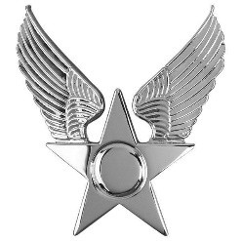
AUTHORIZED AIR FORCE JROTC BADGES AND INSIGNIAHORIZED AIR FORCE JROTC ADGES AND INSIGNIA


Optional Enlisted/Officer Service Cap Insignia

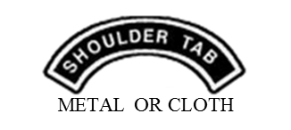

AEF BADGE (NEW)

Marksmanship
Shield

Choose one only. Follow APT placement criteria.
May NOT wear Marksmanship Shield and a
Marksmanship Badge.
Choose one only. Place directly underneath ribbons. May NOT wear Marksmanship Shield and Marksmanship Badge. Do not wear Marksmanship badges with medals.


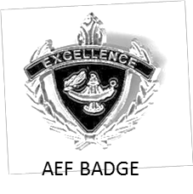
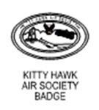
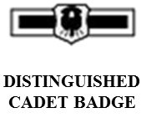
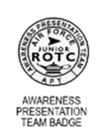
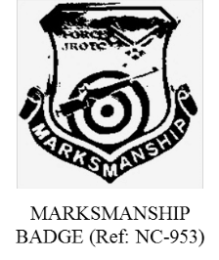
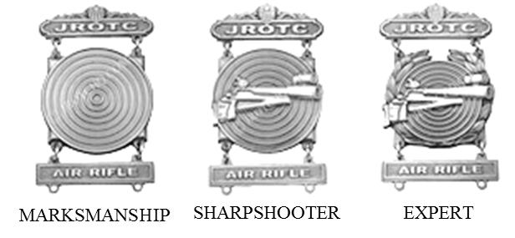
Badges/Insignia not listed here are unauthorized. (Exception for other badges or pins see section 7.2.10)

AIR FORCE JROTC RANK INSIGNIA

CADET OFFICER RANK

SECOND LIEUTENANT
FIRST LIEUTENANT

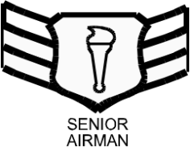
CAPTAIN MAJOR LIEUTENANT COLONEL
COLONEL

NOTE: Cadet Officer rank used is either cloth epaulet or collar rank, depending on specific uniform worn.

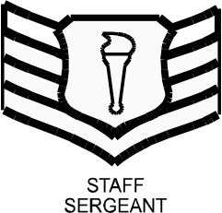
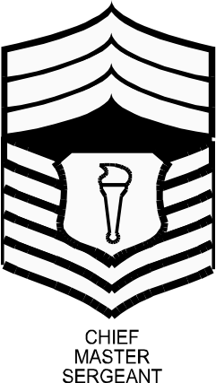
CADET ENLISTED RANK

AIRMAN BASIC: NO RANK INSIGNIA

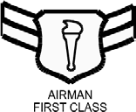
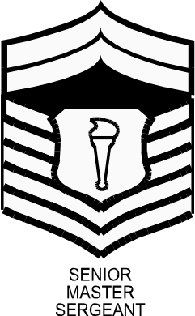
AIRMAN

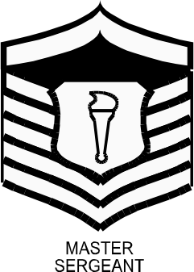
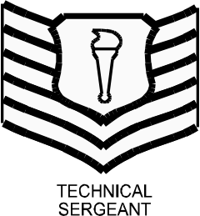

NOTE: Cadet Enlisted rank used is small collar rank only, regardless of uniform worn

Rank insignia not listed here is unauthorized. The First Sergeant device is not authorized.

CADET MALE HEADGEAR

SERVICE CAP (Officer and Enlisted)

Centered

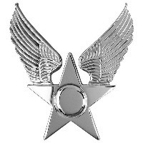

Black hat band

Plain Black

Officer Service Cap may also be worn with the large officer service cap insignia.

FLIGHT CAP* (Officer and Enlisted)


1 ½” 

• Enlisted Ranks will have no hat insignia on the flight cap.
• The former officer flight cap emblem will not be worn on the flight cap.

Attachment 7-4

CADET FEMALE HEADGEAR

SERVICE CAP (Officer Only)

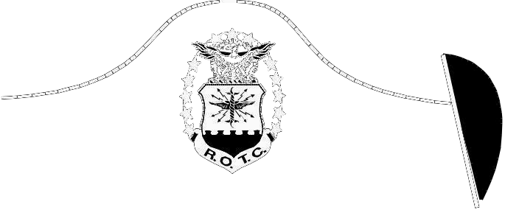
Solid Blue Color with no embroidery

Centered

Enlisted Women’s Service Caps may be worn with the Hap Arnold Wings insignia.

FLIGHT CAP* (Officer and Enlisted)

1 ½”

• Enlisted Ranks will have no hat insignia on the flight cap.
• The former officer flight cap emblem will not be worn on the flight cap.

Attachment 7-5

CADET ABU Male and Female

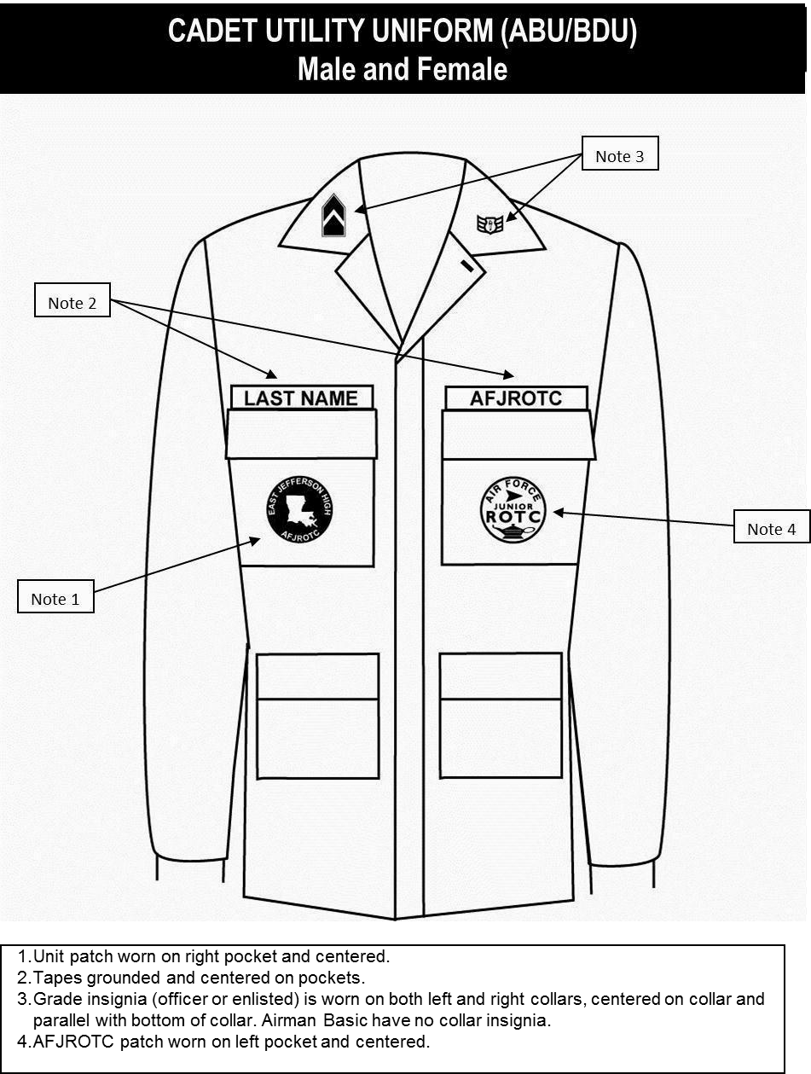

1. Unit patch (optional). If worn, will be placed on right pocket and centered. (AF Funds may not be used to procure unit patches.)
2. Last Name and AFJROTC tapes, dark blue (mandatory). Tapes are grounded and centered on pockets. Name tape only may be held with Velcro to enable reuse/reissue to a different cadet.
3. Grade insignia (officer or enlisted) (mandatory). Will be worn on the left and right collars, centered on collar and parallel with bottom of collar. Airman Basic have no collar insignia.
4. AFJROTC patch: WHITE patch only (mandatory). Will be worn on left pocket and centered.

Attachment 7-6

CADET ABU HEADGEAR

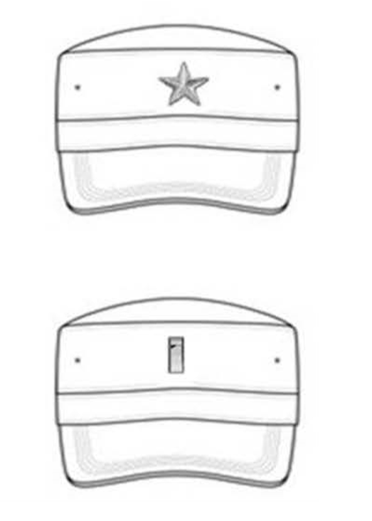

Enlisted Cadets will not wear rank on the ABU cap.

Officers will wear rank insignia on the ABU cap.

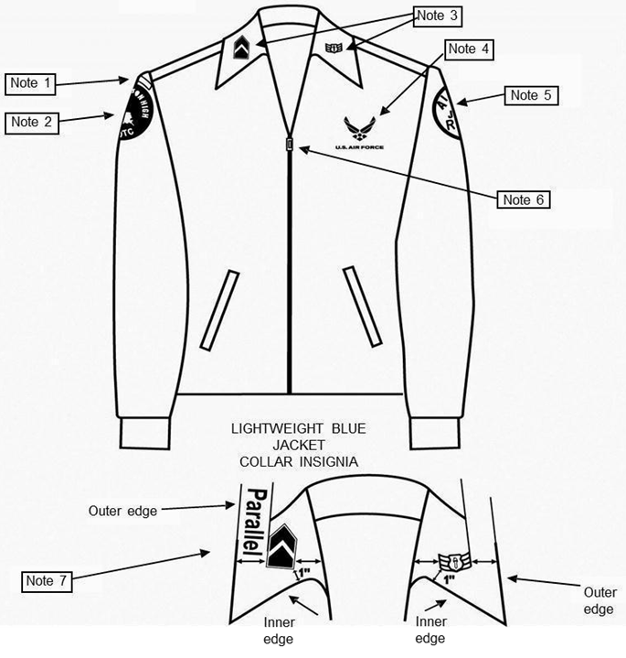
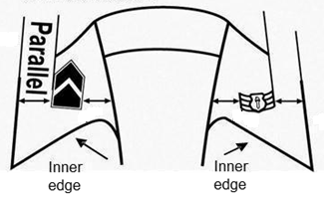
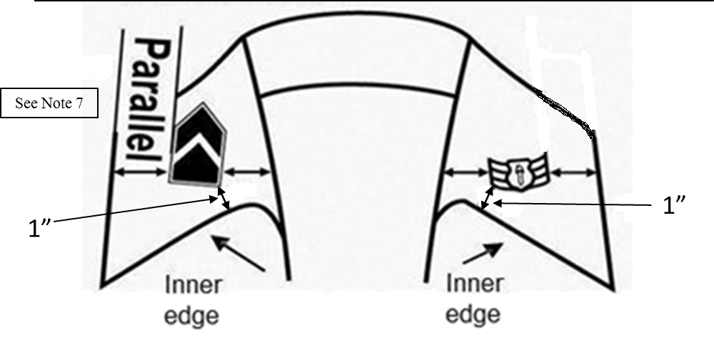

See Note 7

1”
1”

(Picture Not To Scale)
CADET LIGHTWEIGHT BLUE JACKET

NOTE: The epaulet rank is no longer authorized on the lightweight blue jacket.

Centered halfway

Drawing not to scale

1. Shoulder tabs are centered between unit patch and shoulder seam. If no patch, then 1 inch below shoulder seam.
2. Unit patch on right ½ to 1 inch below shoulder seam and centered.
3. Grade insignia (officer and enlisted) worn on both lapels, mandatory. Place insignia centered
halfway up the lapel. Bottom of insignia is horizontal with the ground.
4. Optional item: center vertically between the shoulder seam and where the underarm side
seam joins the armhole sleeve and center horizontally between the center zipper and the sleeve
armhole seam.
5. AFJROTC patch on left sleeve ½ to 1 inch below shoulder seam centered.
6. Jacket will be closed to at least the halfway point.
7. Center insignia horizontally on collar. Place 1 inch from bottom of collar and parallel to the
outer edge of the collar.
8. Enlisted rank insignia MUST be worn on the blue shirt while wearing the light weight jacket.

CADET MALE SERVICE DRESS

Note 17

Note 16

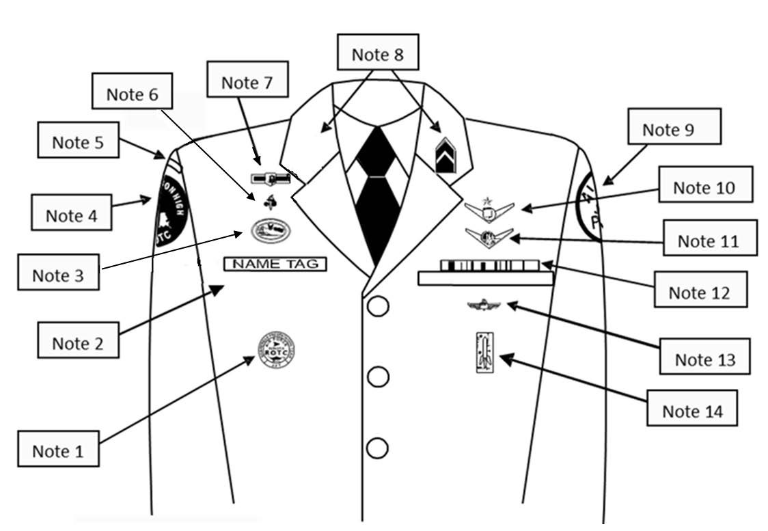




1. Awareness Presentation Team (APT) Badge. Centered 3 inches below the bottom of the silver name tag.
2. Silver Name tag, mandatory. Center on the right side between arm seam and lapel with bottom edge parallel
to top of welt pocket.
3. Kitty Hawk Badge. See Note 15 below.
4. Unit patch. Place ½ to inch below shoulder seam and centered.
5. Shoulder tab: Center between unit patch and shoulder seam. If no patch, then 1 inch below shoulder seam.
6. Aerospace Education Foundation (AEF) Badge. See Note 15 below.
7. Distinguished Cadet Badge. See Note 15 below.
8. Grade insignia (officer and enlisted) worn on both lapels, mandatory. Place insignia halfway up the seam,
resting on but not over it. Bottom of insignia is horizontal with the ground.
9. AFJROTC Patch: Place ½ to 1 inch below shoulder seam and centered.
10. Flight Solo or Flight Certificate Badge. See Note 15 below.
11. Ground School Badge. See Note 15 below.
12. Ribbons, mandatory. Centered, on but not over edge of pocket. Wear 3 or 4 in a row. Wear all or some
ribbons earned.
13. Academy of Model Aeronautic (AMA) Wings. Worn 1 inch below pocket.
14. Model Rocketry Badge. Worn 2 inches below AMA Wings or 3 inches below pocket if no AMA Wings are
worn.
15. First badge placed ½ inch above silver name tag or ribbons and is centered horizontally. Additional badges
are placed ½ inch above previous badge.
16. Shoulder Cord. No wider than 1 inch and will be grounded to the seam of the left shoulder.
17. Enlisted rank insignia MUST be worn on the blue shirt while wearing the service dress.
18. Medals are not authorized for wear on this uniform with ribbons. Ribbons and medals may not be mixed.

Note 16

Note 17

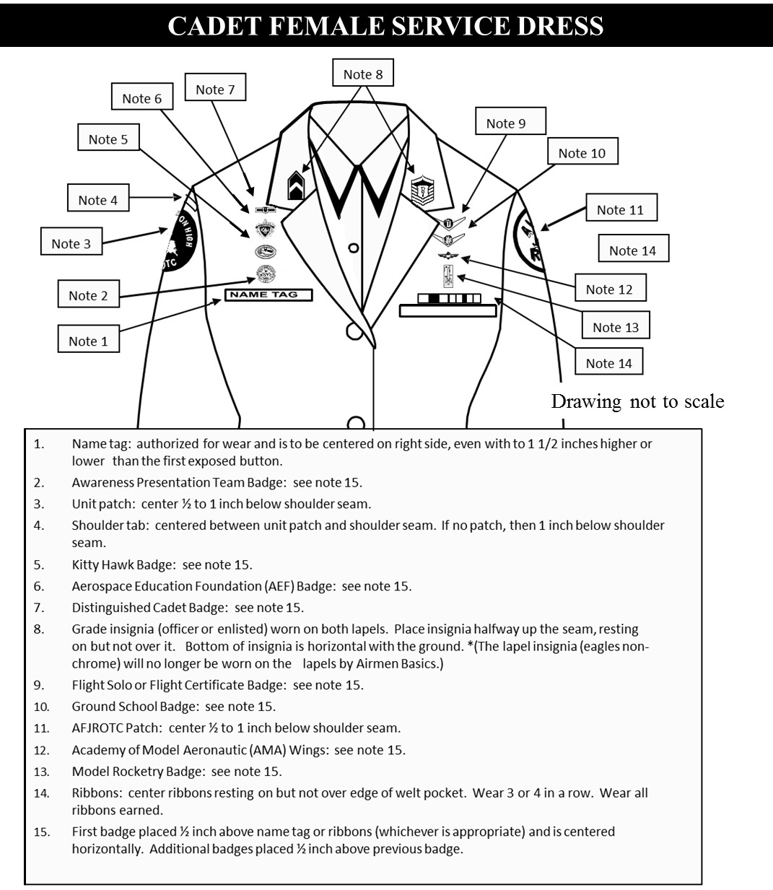

Drawing not to scale

1. Silver Name tag, mandatory. Center on the right side between arm seam and lapel with bottom edge even with to 1 ½ inch higher or lower than the first exposed button.
2. Awareness Presentation Team Badge. See Note 15 below.
3. Unit patch. Center ½ to 1 inch below shoulder seam
4. Shoulder tab: Center between unit patch and shoulder seam. If no patch, then 1 inch below
shoulder seam
5. Kitty Hawk Badge. See Note 15 below.
6. Aerospace Education Foundation (AEF) Badge. See Note 15 below.
7. Distinguished Cadet Badge. See Note 15 below.
8. Grade insignia (officer and enlisted) worn on both lapels, mandatory. Place insignia halfway up the
seam, resting on but not over it. Bottom of insignia is horizontal with the ground.
9. Flight Solo or Flight Certificate Badge. See Note 15 below.
10. Ground School Badge. See Note 15 below.
11. AFJROTC Patch, mandatory. Center ½ to 1 inch below shoulder seam.
12. Academy of Model Aeronautic (AMA) Wings. Worn 1 inch below pocket.
13. Model Rocketry Badge. Worn 2 inches below AMA Wings or 3 inches below pocket if no AMA Wings
are worn.
14. Ribbons, mandatory. Center ribbons resting on but not over edge of welt pocket. Wear 3 or 4 in a
row. Wear all or some ribbons earned.
15. First badge placed ½ inch above silver name tag or ribbons and is centered horizontally. Additional
badges are placed ½ inch above previous badge.
16. Shoulder Cord. No wider than 1 inch and will be grounded to the seam of the left shoulder.
17. Enlisted rank insignia MUST be worn on the blue shirt while wearing the service dress.
18. Medals are not authorized for wear on this uniform with ribbons. Ribbons and medals may not
be mixed.

CADET MALE BLUE SHIRT

Note 9

Note 16

Note 10

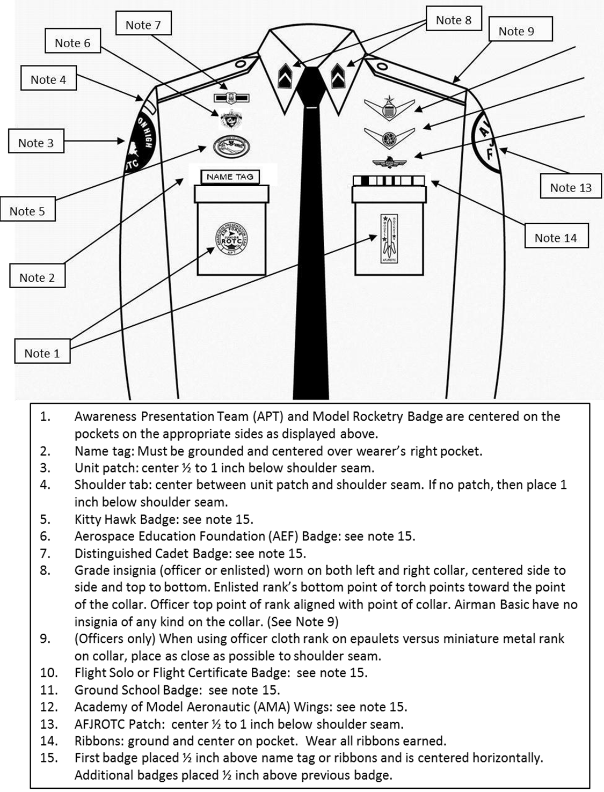

Note 11

Note 12

Drawing not to scale

1. Awareness Presentation Team (APT) and Model Rocketry Badge are centered on the pockets on the appropriate sides as displayed above.
2. Name Tag: Mandatory wear. Blue Plastic with white letters. Must be grounded and centered over wearer’s right pocket.
3. Unit patch. Centered ½ to 1 inch below the shoulder seam.
4. Shoulder tab. Centered between unit patch and shoulder seam. If no patch, then place 1 inch below
shoulder seam.
5. Kitty Hawk Badge. See Note 15.
6. Aerospace Education Foundation (AEF) Badge. See Note 15.
7. Distinguished Cadet Badge. See Note 15.
8. Grade insignia, mandatory (officer and enlisted) worn on both left and right collar, centered side to side
and top to bottom. Enlisted rank’s bottom point of torch points towards the point of the collar. Officer
top point of rank aligned with point of collar. Cadet/Amn Basic have no insignia of any kind on the collar.
9. Officers only. When using officer cloth rank on epaulets versus miniature metal rank on collar, place as
close as possible to shoulder seam. (Use larger male epaulets only).
10. Flight Solo or Flight Certificate Badge. See Note 15.
11. Ground School Badge. See Note 15.
12. Academy of Model Aeronautic (AMA) Wings. See Note 15.
13. AFJROTC Patch, mandatory. Center ½ to 1 inch below shoulder seam.
14. Ribbons are optional. Wear all, some or no ribbons earned. If worn, ribbons will be centered, resting on,
but not over the edge of the pleated pocket on the wearers left.
15. First badge placed ½ inch above name tag or ribbons and is centered horizontally. Additional badges
placed ½ inch above previous badge.
16. Shoulder Cord. No wider than 1 inch and will be grounded to the seam of the left shoulder under epaulet
17. Medals (regardless of what type) are not authorized for wear on this uniform.

CADET FEMALE BLUE SHIRT

Note 9

Note 5
Note 4
Note 17

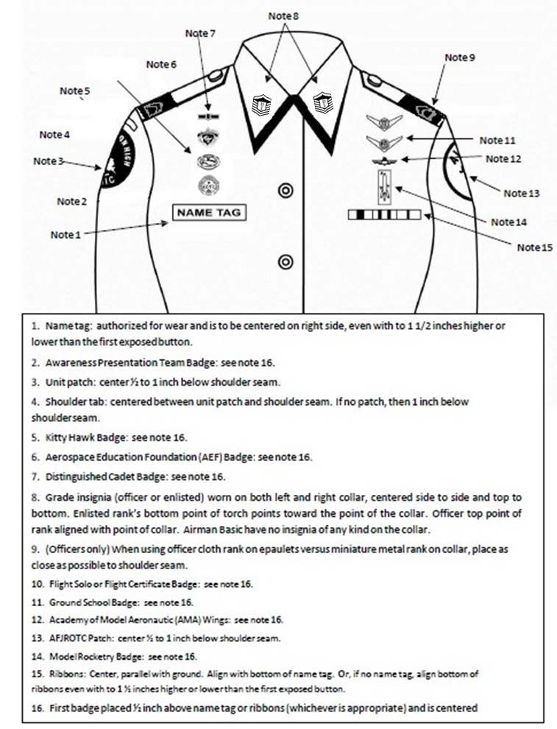

Note 10

Drawing not to scale

1. Name Tag: Mandatory wear. Blue Plastic with white letters. Without ribbons: centered on right side, parallel to ground and within 1 ½ inches higher/lower than topmost exposed button. With Ribbons: Even with bottom row of ribbons, centered on right side, parallel to ground and within 1
½ inches higher/lower than topmost exposed button.
2. Awareness Presentation Team (APT) Badge. See Note 16
3. Unit Patch. Centered on sleeve and ½ to 1 inch below shoulder seam.
4. Shoulder Tab (Metal or cloth). Centered between unit patch and shoulder seam. If no patch,
then 1 inch below shoulder seam.
5. Kitty Hawk Air Society Badge. See Note 16.
6. Aerospace Education Foundation (AEF) Badge. See Note 16.
7. Distinguished Cadet Badge. See Note 16.
8. Grade insignia, mandatory (officer and enlisted) worn on both left and right collar, centered side
to side and top to bottom. Enlisted rank’s bottom point of torch points towards the point of the
collar. Officer top point of rank aligned with point of collar. Cadet/Amn Basic have no insignia of
any kind on the collar
9. Officers only. When using officer cloth rank on epaulets versus miniature metal rank on collar,
place as close as possible to shoulder seam. (Use smaller female epaulets only)
10. Flight Solo or Flight Certificate Badge. See Note 16.
11. Ground School Badge. See Note 16.
12. Academy of Model Aeronautics (AMA) Wings. See Note 16.
13. AFJROTC Patch, mandatory. Center on sleeve ½ to 1 inch below shoulder seam.
14. Model Rocketry Badge. See Note 16.
15. Ribbons are optional. Wear all, some or no ribbons earned. If worn, center ribbons on wearer’s
left, parallel with ground. Align bottom of the ribbons with the bottom of the name tag.
16. First badge is centered ½ inch above name tag or ribbons (as appropriate).
17. Shoulder Cord. No wider than 1 inch and will be grounded to the seam of the left shoulder under
the epaulet.
18. Medals (regardless of what type) are not authorized for wear on this uniform.

FLIGHT SUIT (Male and Female)

Note 2
Note 3

Note 1
Note 4

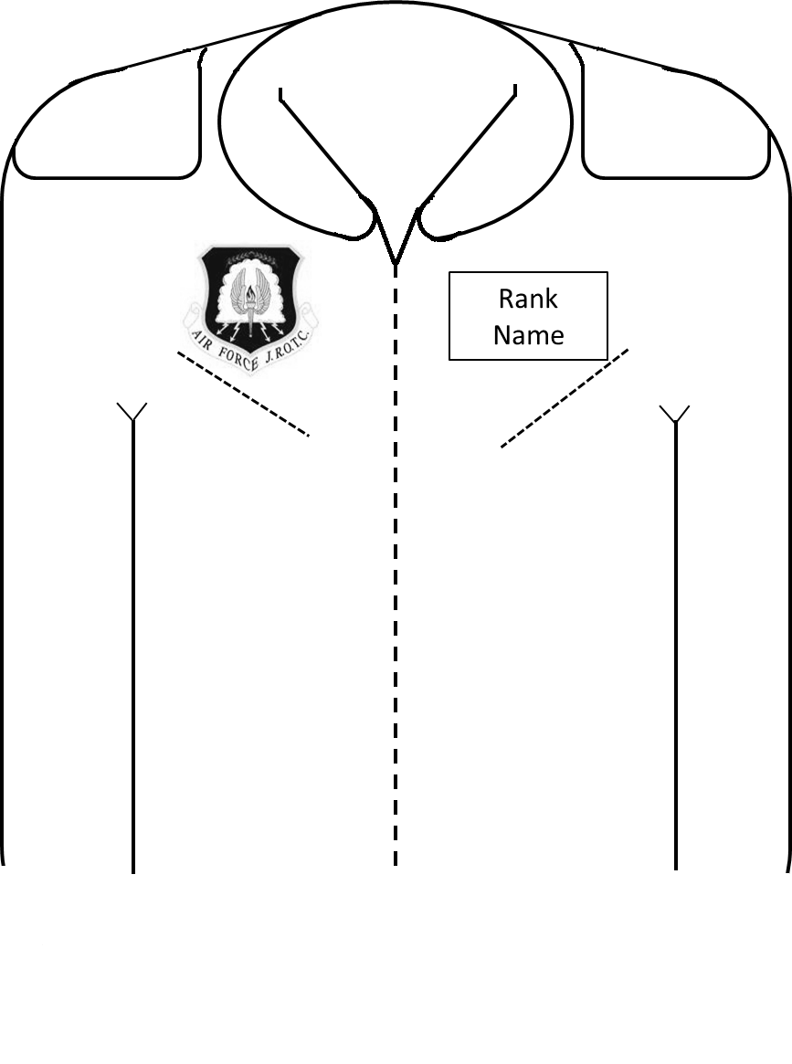
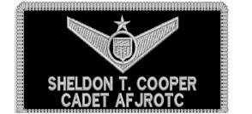

1. * AFJROTC Command Patch (mandatory). Velcro attached. This style of patch may only be worn on the Flight Suit. Cadets can only wear ground school, flight solo or flight certificate badges upon successful completion those programs (See Ops Supplement, Chapter 7, paras 7.2.1, 7.2.2 and 7.2.3).
2. * AFJROTC (white “Lamp of Knowledge”) Patch (mandatory). Velcro attached.
3. * American Flag Patch (mandatory). Velcro attached.
4. * Cadet Rank and Cadet Name Patch (mandatory). Velcro attached. Black
background with silver border/cadet rank/name.
5. Flight Suits are authorized for those cadets currently enrolled in or that have
successfully completed aviation honors ground school, been awarded a
flight solo badge, flight certificate badge or have successfully completed the
AFJROTC Flight Academy program.

* Flight patches may be purchased from a vendor using MilPer funds.

Semi-Formal Dress Uniform

Note 1

Note 2

Note 6

Note 3
Note 4 Note 5

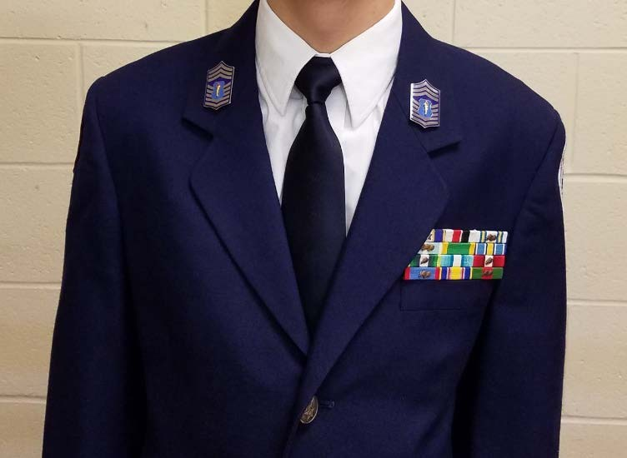
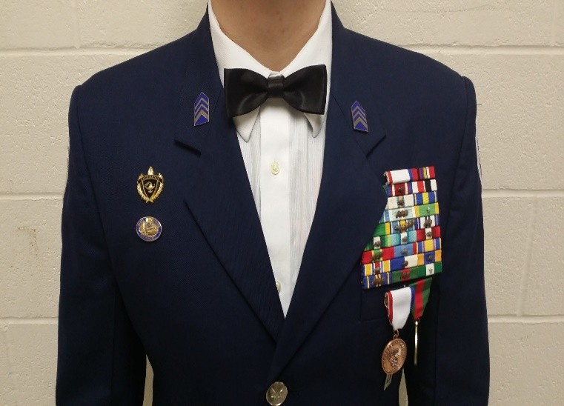

1. The blue or white long-sleeve shirt will be plain, knit or woven, commercial type with a short or medium point collar, with button or French cuffs.
2. Enlisted members do not need to wear two sets of ranks on the semi-formal uniform.
3. The Silver Name Tag will not be worn on the semi-formal dress uniform.
4. Black or Blue bow tie may be worn with the semi-formal uniform (white shirt only).
5. Ribbons will not be worn on the semi-formal uniform. Large medals may be worn on the
Service Dress coat only, directly under ribbon rack.
6. Authorized badges may be worn on the semi-form dress uniform. If medals are worn,
badges that are normally worn directly under the ribbon rack will not be worn.
7. Headgear is not worn with the semi-formal dress uniform.

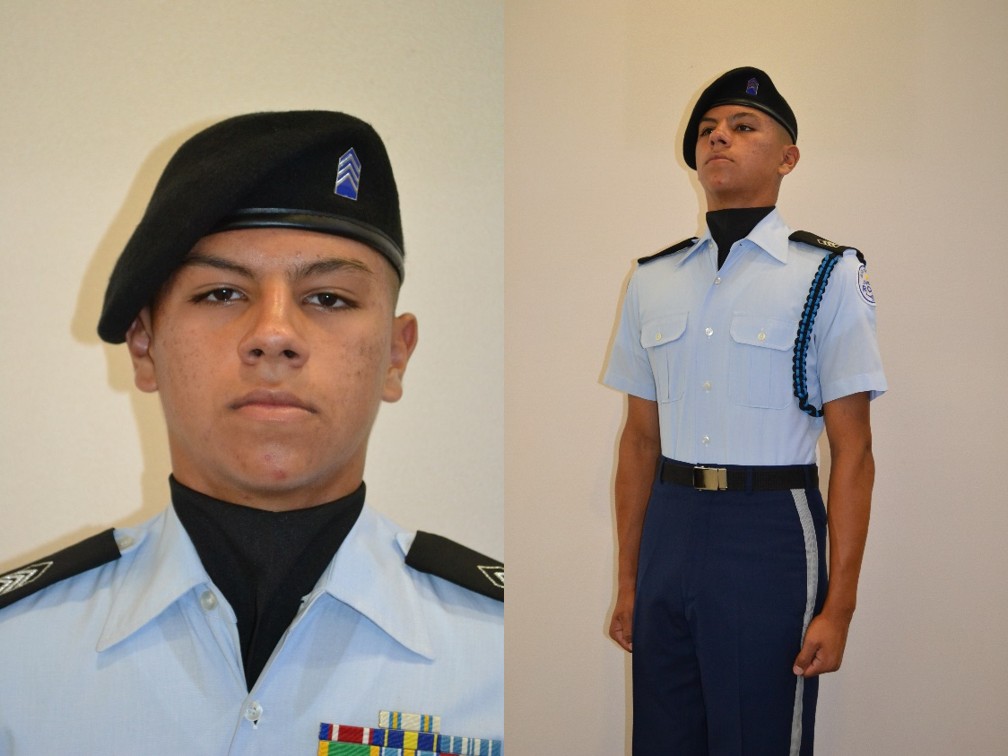
Sample Exhibition Uniform

¾ inch
stripe

1. Berets. Solid Color, white, dark blue and/or black ONLY, with AFJROTC officer and/or enlisted rank insignia and mini-Hap Arnold Insignia. The former officer flight cap emblem will not be worn on the beret.
2. Shoulder Cord. Cadets are authorized to wear one shoulder cord on the left shoulder. This will be a single “infantry” style cord, without metal tips, no more than 1-inch wide. On the blue shirt the cord will be under the epaulet, grounded to the left shoulder seam and pinned to the shoulder with the pin hidden beneath the cord.
3. Blue/Silver Name Tags and ribbons may be omitted on uniforms where a drill rifle or other equipment may damage the item or injure the performing member. This does not apply to uniforms worn during regular uniform days.
4. Blue pants may be modified to have a ¾ inch stripe on the outside length of the pants,
silver, dark blue, and/or black only. These items will not be worn on regular uniform days. .
5. Solid color ascots may be worn, colors may be locally-determined (school colors), but must
be conservative and in good taste, and defined in the Cadet Guide or Unit Operations
Instruction. Ascots will not be worn on regular uniform days.
6. Embroidery on the Air Force blue drill team uniform is not authorized, i.e., on the back of
the blue shirt collar or shoulder yoke.
7. Specialized unit rank/shoulder boards are not authorized.
8. Wrist bands are not authorized.
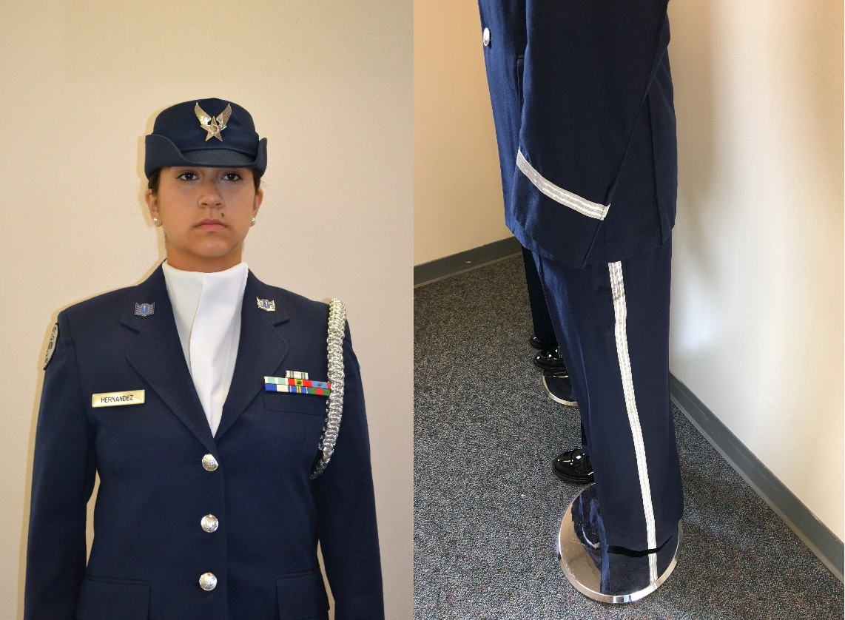
Sample Exhibition Uniform

¾ inch
stripe

1. Women’s Service Caps may be worn with the Hap Arnold Wings insignia or Officer Service Cap may also be worn with the large officer service cap insignia large officer’s . Service Caps (wheel and bucket hats) will be a solid color and free of any embroidery.
2. Shoulder Cord. Cadets are authorized to wear one shoulder cord on the left shoulder. This will be a single “infantry” style cord, without metal tips, no more than 1-inch wide. On the blue shirt the cord will be under the epaulet, grounded to the left shoulder seam and pinned to the shoulder with the pin hidden beneath the cord. Cords may be any color.
3. Blue/Silver Name Tags and ribbons may be omitted on uniforms where a drill rifle or other equipment may damage the item or injure the performing member. This does not apply to uniforms worn during regular uniform days.
4. Blue pants may be modified to have a ¾ inch stripe on the outside length of the pants,
silver, dark blue, and/or black only. These items will not be worn on regular uniform days. .
5. Solid color ascots may be worn, colors may be locally-determined (school colors), but must
be conservative and in good taste, and defined in the Cadet Guide or Unit Operations
Instruction. Ascots will not be worn on regular uniform days.
6. Embroidery on the Air Force blue drill team uniform is not authorized, i.e., on the back of
the blue shirt collar or shoulder yoke.
7. Specialized unit rank/shoulder boards are not authorized.
Attachment 7-17
Sample Uniform Pictures

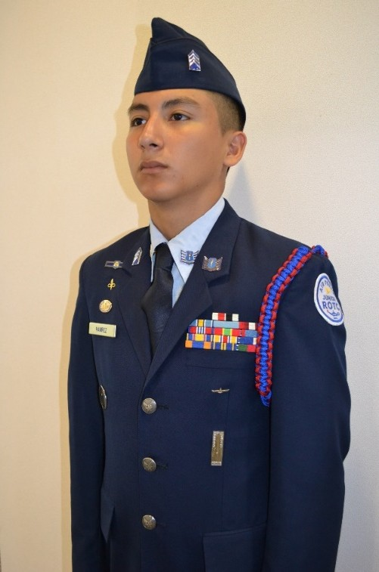
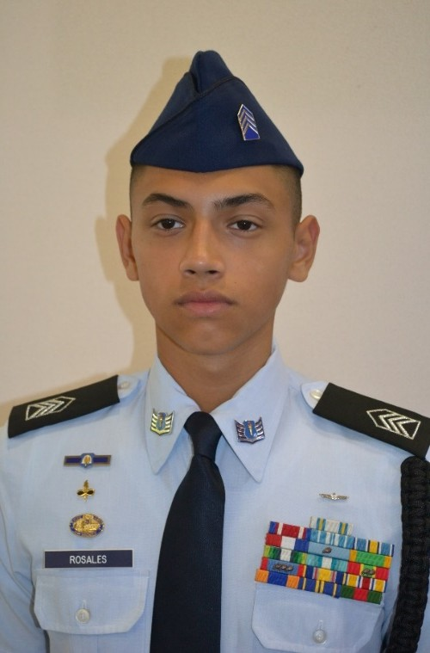

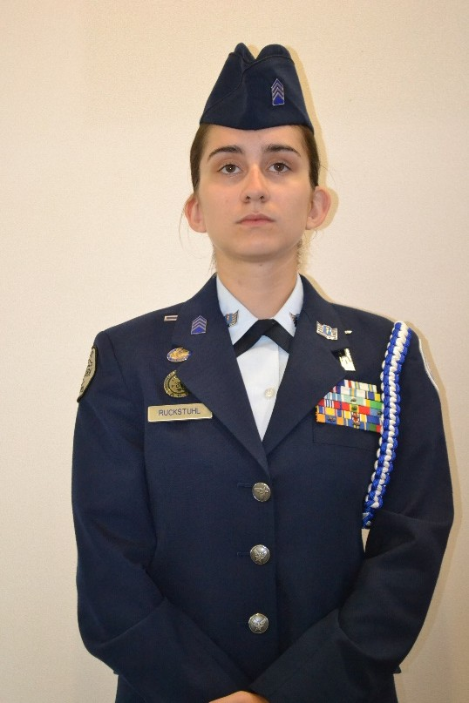
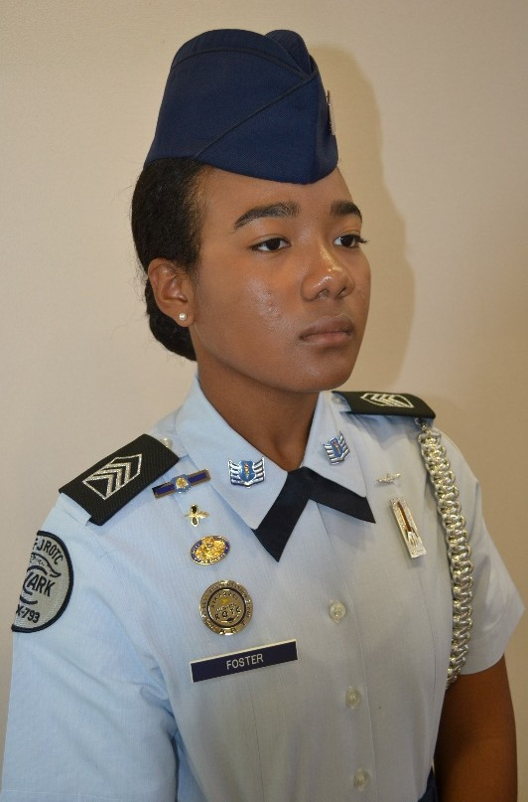
Attachment 7-18
Sample Uniform Pictures

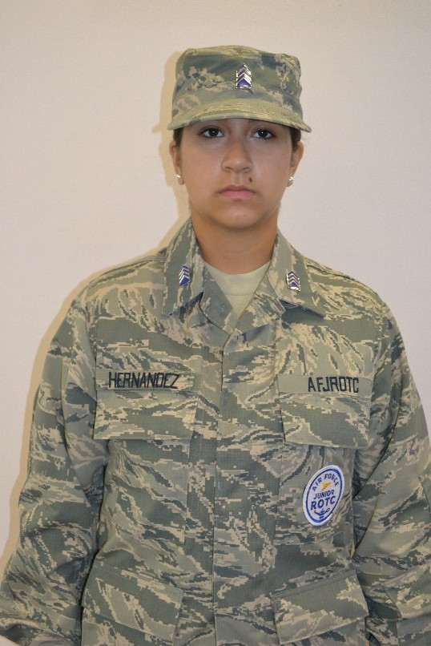

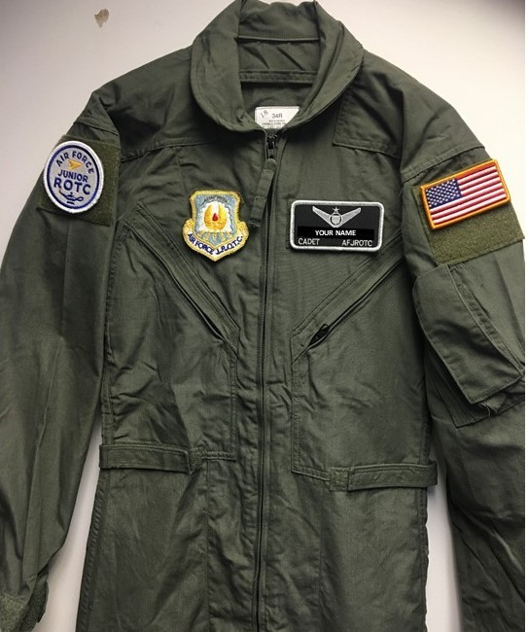
Sample PT Uniform Pictures
Attachment 7-19

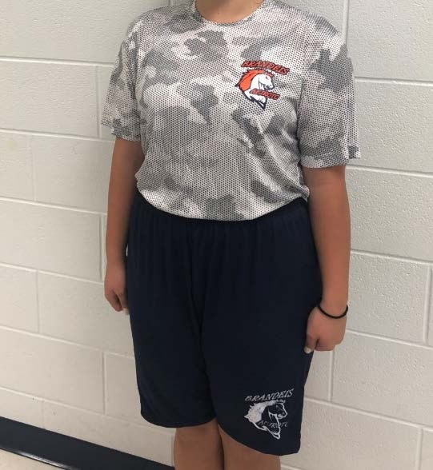

Local Purchased PTG

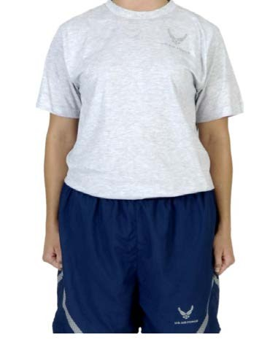

FEDMALL Purchased Air Force PT

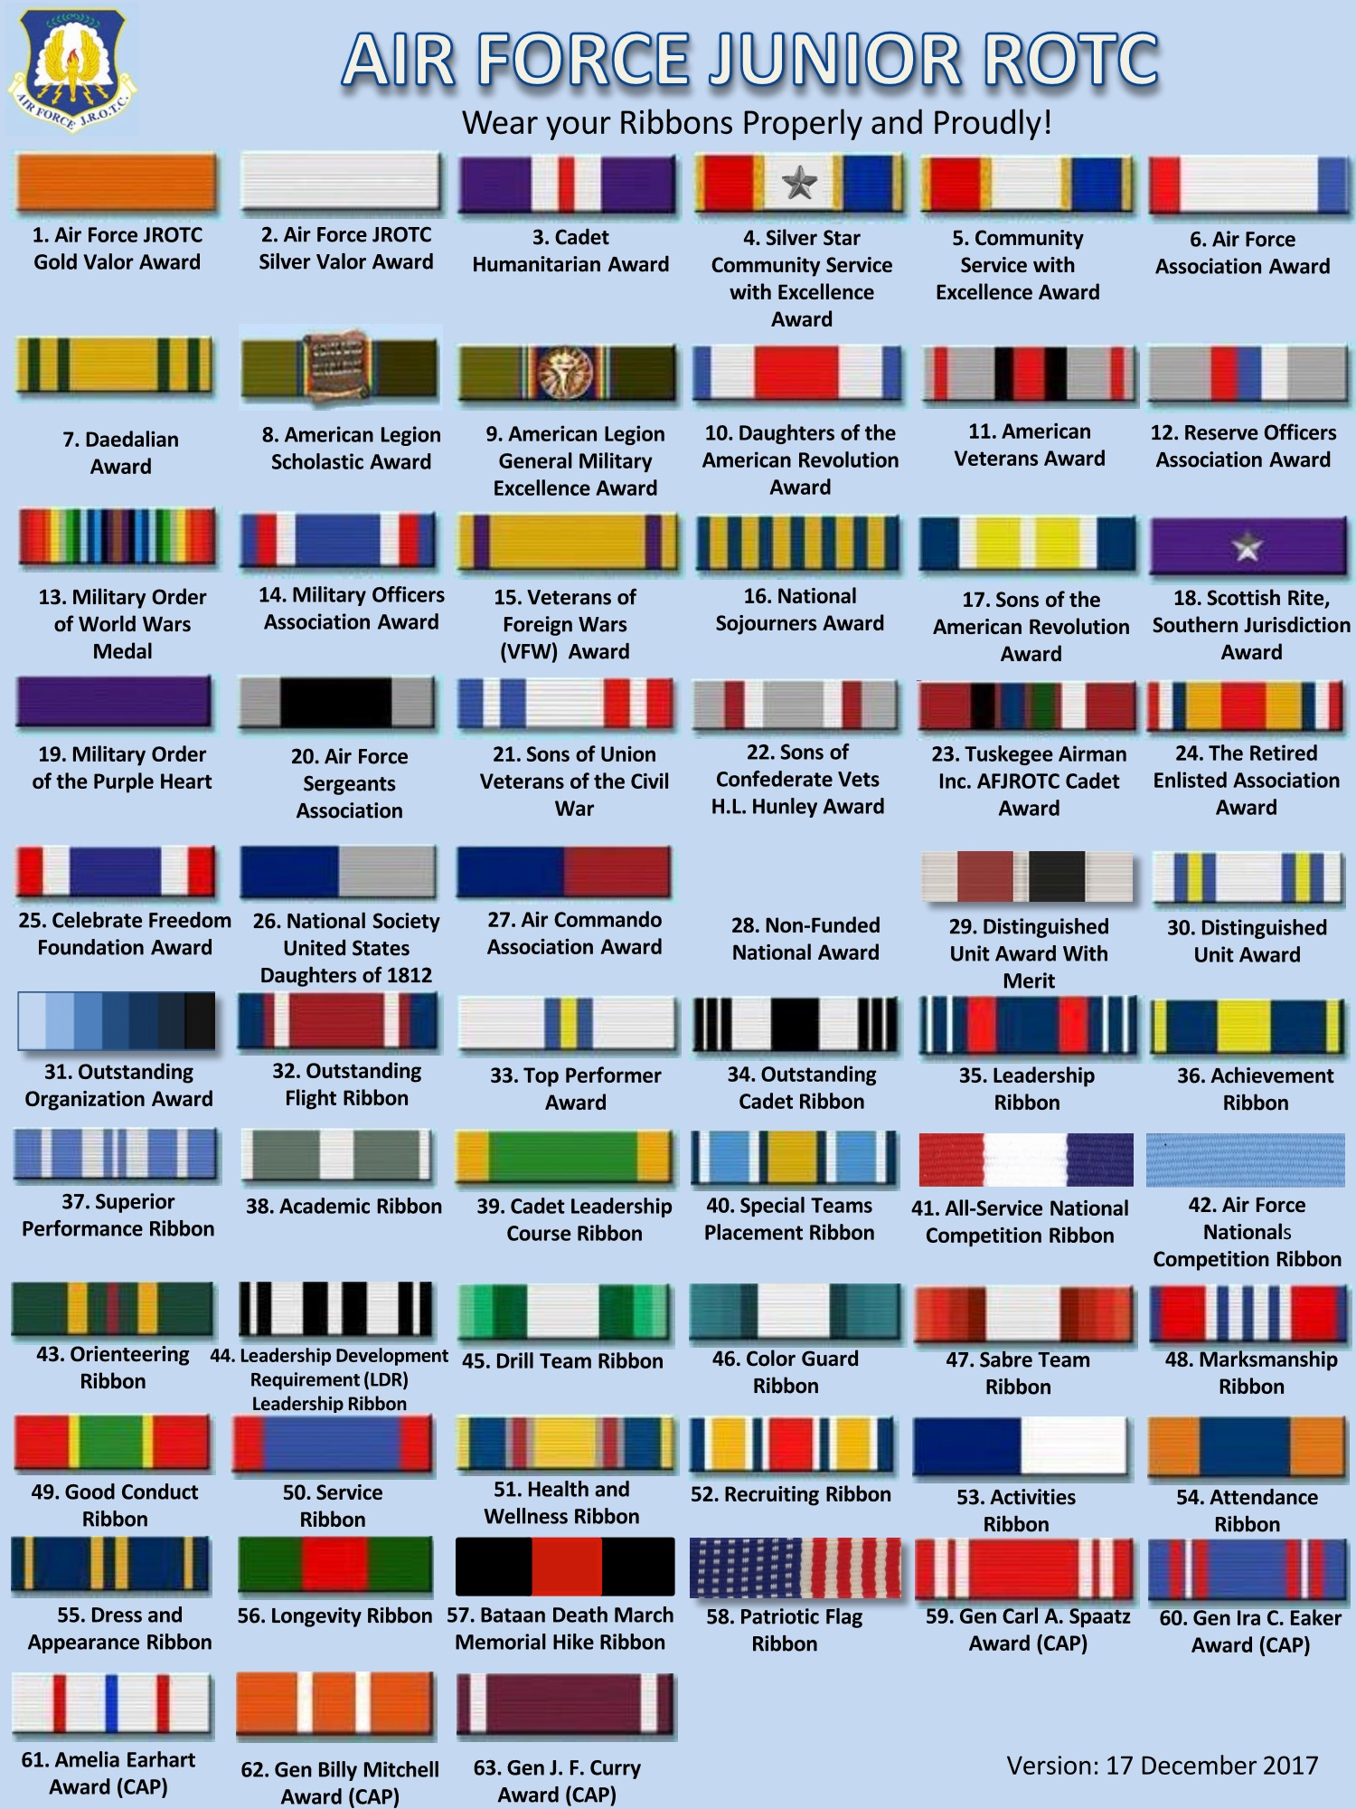
Attachment 7-20

